admi.004.001.02 – system event notification broadcast (MT equivalent: smt700 – status change notification

Scope
An admi.004.001.02 message is sent by CAS to the direct participants when
- CAS business day status has changed (open/close for business);
- CAS operating time has changed;
- CAS settlement status has changed;
- account has been suspended;
- Direct participant has been removed;
- Direct participant has been suspended;
- There was a change in the queue of the direct participant (queue has been created, cleared, or a new transaction order was added to the beginning of the queue).
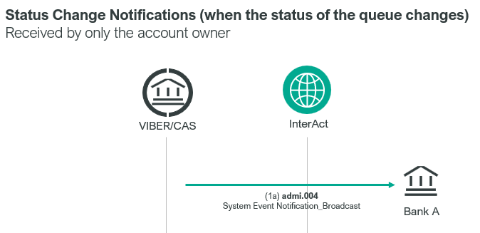
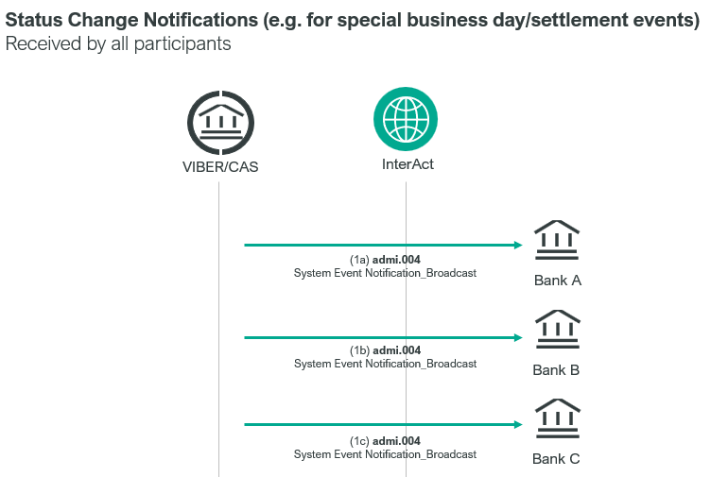
Except for the first and last case all direct participants and financial infrastructures are notified about the status change. Only Third Parties are notified when the CAS business day status has changed. Only the account owner is notified when the status of the queue changes.

Element specification
The below table includes the SWIFT format specification.
M/O | Element | MX options | MT equivalent field | MT equivalent field name
M | AppHdr/Fr/FIId/FinInstnId/BICFI | CAS settlement BIC (MANEHU2AXXX)
M | AppHdr/To/FIId/FinInstnId/BICFI | receiving BIC
M | AppHdr/BizMsgIdr | Business Message Identifier | 20 | Transaction Reference Number
M | AppHdr/MsgDefIdr | admi.004.001.02
M | AppHdr/BizSvc | swift.iap.01
M | AppHdr/CreDt | Creation Date and Time
M | Document/SysEvtNtfctn/EvtInf/EvtCd | Event Code | L01 | CAS Object State
O | Document/SysEvtNtfctn/EvtInf/  EvtParam | Event Parameter  entries for time and validity  if EvtCd=OPOP,OPEC,OPEI or OPET | L01 | CAS Object State
O | Document/SysEvtNtfctn/EvtInf/  EvtDesc | Event Description  - if EvtCd=QBLK:  CAS message details  amount and currency  priority  - if EvtCd contains any other code:  CAS member BIC (repeating) | L02  32B  113  L04 | CAS Message Details  Amount  Business Priority  CAS Member BIC
M | Document/SysEvtNtfctn/EvtInf/EvtTm | Event Time | L12 | CAS Action Time

Format specification
- Event Code shows what element of CAS has been changed and what the current status is. The following codewords can be used in this element:
- Status can be the following:
- OPOP, in the case of opening,
- OPEC, closing of client items
- OPEI, closing of interbank orders
  - OPET, in the case of a change in the cut-off time for payment and settlement orders submitted by system operators.
The new value of the modified data (HHMM) and the validity period of the change are indicated in the Event Parameter in two separate elements:
- TODAY, if it is only for the current day, or
- EVERY, if its valid for all business days after the reference date
Event Code | Event Parameters | incident (for example)
OPOP | 0850  EVERY | Change in the time of CAS opening/ daily/ new time 08:50
OPOP | 0850  TODAY | Change in the time of CAS opening / today / new time 08:50
OPEC | 1730  TODAY | change in the cut-off time for client items/today/new date 17:30
OPEI | 1830  TODAY | change in the cut-off time for interbank orders/today/new time 18:30
OPET | 1830  TODAY | Change in the cut-off time for payment and settlement orders submitted by system operators/today/new time 18:30
OPEC | 1730  EVERY | change in the cut-off time for client orders/ daily/ new time 17:30
OPEI | 1830  EVERY | change in the cut-off time for interbank orders/daily/new time 18:30
OPET | 1830  EVERY | Change in the cut-off time for payment and settlement orders submitted by system operators/daily/new time 18:30
If more than one time change occurs simultaneously, a separate admi.004.001.02 SWIFT message will be sent for each event.

example:
<EvtParam>1900</EvtParam>
<EvtParam>TODAY</EvtParam>
- Queue status can be the following:
- QBLK when a queue was created for the direct participant due to lack of sufficient funds or a new order has been added to the top of the queue.
- QCLR when the queue has been cleared.
- Organisation (direct participant) status can be:
- ORDE when the direct participant has been excluded and payment transaction to the credit or debit of it are rejected.
- ORND when a former “defaulted” direct participant has been un-blocked.
- ORSU, when all accounts of the direct participant have been suspended. However, in this case the payment transactions received to the credit or debit of it are queued by VIBER.
- ORNS when the suspended status has been removed.
- Account status can be the following:
- ACSU, when one account has been suspended in CAS for both credit and debit transactions.
- ACSC when one account is suspended for credits in CAS
- ACSD when one account is suspended for debits in CAS
- ACNS when the suspended status has been removed.
- CAS status can be the following:
  - CAOP, the CAS is open
  - CACL, the CAS is closed
Event Code | Event Parameter | incident
CAOP | YYYY-MM-DDTHH:MM:SS+00:00 | CAS opened at the time indicated in Event Parameter
CACL | YYYY-MM-DDTHH:MM:SS+00:00 | CAS closed at the time indicated in Event Parameter

- CASU when operation of CAS has been suspended
Event Code | Event Parameter | incident
CASU | YYYY-MM-DDTHH:MM:SS+00:00 | the operation of CAS was suspended at the time indicated in Event Parameter
- CANS when the suspended status of CAS has been removed.
Event Code | Event Parameter | incident
CANS | YYYY-MM-DDTHH:MM:SS+00:00 | the suspension of CAS was cancelled at the time indicated in Event Parameter

When Event Code contains the codeword QBLK then the admi.004.001.02 message will include also the Event Description element, which includes the former MT field L02, 32B and 113 concatenated with MT field tag, separated by “//”, and with decimal point in amount.
- Field L02 (CAS Message Details) identifies the transaction order at the start of the queue.
- Field 32B (Amount) includes the currency code and amount of the first transaction order in the queue.
Field 113 (Business Priority) contains the priority of the transaction order at the start of the queue. E.g.: "L02 D231028100100BACXHUHBXXX9610280000981//32B HUF123.00//113 0050"
If Event Code includes any of the other codewords then the Event Description will include only the former MT.
- Field L04 (CAS Member BIC) includes the BIC code of the direct participant or account holder that has been suspended, locked out or whose suspension or lock-out has been removed.
E.g. “L04 OTPVHUHB”

Examples
- OTP Bank receives an admi.004.001.02 SWIFT message from CAS informing that the uptime for interbank orders have been extended for the current day, with the new cut-off time being 19:00.
mnb.hu/letoltes/admi-004-001-02-1-viber.txt
- OTP Bank receives an admi.004.001.02 SWIFT message from CAS, notifying them that a queue was generated as they did not have sufficient funds on their accounts to settle the transaction order shown in Event Description.
mnb.hu/letoltes/admi-004-001-02-2-viber.txt

- All direct participants, including UniCredit Bank receives an admi.004.001.02 SWIFT message from CAS, announcing that the accounts of OTP Bank have been suspended in CAS.
mnb.hu/letoltes/admi-004-001-02-3-viber.txt
- Each direct participant, including UniCredit Bank receives an admi.004.001.02 message from CAS, with the information that the account of OTP Bank has been suspended in CAS.
mnb.hu/letoltes/admi-004-001-02-4-viber.txt

