admi.007.001.01 Invalid input received notification (MT equivalent: MT 298/SMT 900 – Invalid Input Received Notification – Invalid incoming message
  - Scope

CAS uses an admi.007.001.01 message to notify the direct participant that the message they sent was refused due to invalid format.
KELER and GIRO Zrt. receives an admi.007.001.01 message from CAS when the message sent by KELER and GIRO Zrt. contained invalid formatting.

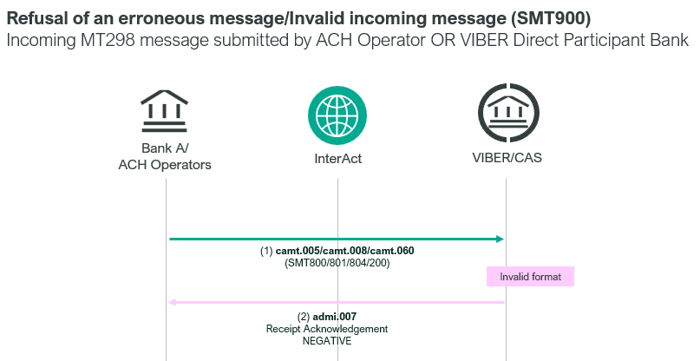

- Element specification
The below table includes the SWIFT format specification.
M/O | Element | MX options | MT equivalent field | MT equivalent field name
M | AppHdr/Fr/FIId/FinInstnId/BICFI | CAS settlement BIC (MANEHU2AXXX) | n/a
M | AppHdr/To/FIId/FinInstnId/BICFI | Receiving BIC | n/a
M | AppHdr/BizMsgIdr | Business Message Identification | n/a
M | AppHdr/MsgDefIdr | admi.007.001.01 | n/a
M | AppHdr/BizSvc | swift.iap.01 | n/a
M | AppHdr/CreDt | Creation Date and Time | n/a
M | Document/RctAck/MsgId/MsgId | Message Identification | 20 | Transaction Reference Number
M | Document/RctAck/Rpt/RltdRef/Ref | Related Reference | 21 | Related Reference
M | Document/RctAck/Rpt/ReqHdlg/StsCd | Status Code | L10 | CAS Message Status  without message line  third character removed
M | Document/RctAck/Rpt/ReqHdlg/StsDtTm | Status Date Time | L12 | CAS Action Time
M | Document/RctAck/Rpt/ReqHdlg/Desc | Description  e.g. camt.060.001.05 | 12 | Message Type

- Format specification
- Document/RctAck/Rpt/ReqHdlg/Desc element contains the type of the invalid and refused message e.g. “camt.060.001.05”
- Document/RctAck/Rpt/ReqHdlg/StsCd element shows the reason for refusal.
LN00 – Payment settled
LT00 – Payment awaiting settlement
LT01 – Payment held
LF00 – Invalid message content
LF01 – Invalid BIC
LF02 – Invalid code word
LF03 – Unexpected field
LA70 – Aborted due to authentication failure
LA71 – Aborted as submitting or receiving Member is unknown
LA72 – Aborted on entry or when queued and the settlement status for the payment type has been set to ‘closed’, ‘rejecting’ or ‘finished’ (i.e. CAS has stopped accepting or processing payments of this type)
LA73 – Aborted due to invalid value date
LA74 – Aborted as payment entry not permitted for payments of this type
LA75 – Not used
LA76 – Aborted due to participant organisation being placed in default
LA77 – Duplicate payment
LA78 – Invalid payment
LA79 – Cancelled
LA80 – Error in CAS
LA81 – Invalid Format
LA82 – Insufficient funds (for submitter types configured not to allow payments to queue where there are insufficient funds)
LA83 – Amount is less than the minimum allowed amount for the payment message type
LA84 – Non eligible debit account
LA85 – Non eligible credit account
LA86 – Rejected by AML Filter
LA87 – Rejected by operator
- Examples
- OTP Bank sent a camt.060.001.05 message in which element Document/AcctRptgReq/RptgReq/AcctOwnr/Pty/Id/OrgId/AnyBIC contained an invalid BIC code. As a response they receive the following admi.007.001.01 message from CAS, which includes the reasons why their order was refused (Document/RctAck/Rpt/ReqHdlg/StsCd).
mnb.hu/letoltes/admi-007-001-01-1-viber.txt
- KELER sent a pacs.010.001.03 message to CAS, which contained invalid formatting, and CAS responded with the following admi.007.001.01 message.
mnb.hu/letoltes/admi-007-001-01-2-viber.txt
- GIRO Zrt. sent a pacs.010.001.03 message in an erroneous format to CAS, in response to which CAS sent the following admi.007.001.01 message.
mnb.hu/letoltes/admi-007-001-01-3-viber.txt

