camt.005.001.08 get transactions - Enquiries from direct participants (mt equivalent: Mt298/Smt800 PAYMENT ENQUIRY REQUEST, MT298/SMT804 DETAILS OF OUTSTANDING OPERATIONS REQUEST AND MT298/SMT805 QUERYING PAYMENT AND SETTLEMENT ORDERS FROM SYSTEM OPERATORS)
  - Scope
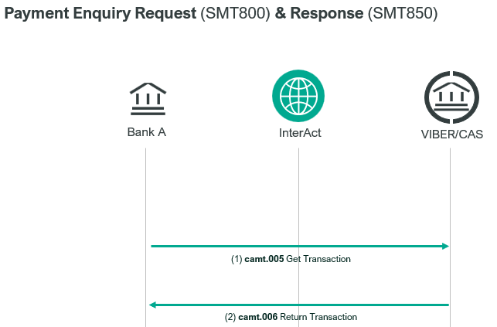
A direct participant can use a camt.005.001.08 message to query information about their own debit orders or about credit orders in their favour. CAS responds with a camt.006.001.08 message to the enquiry.
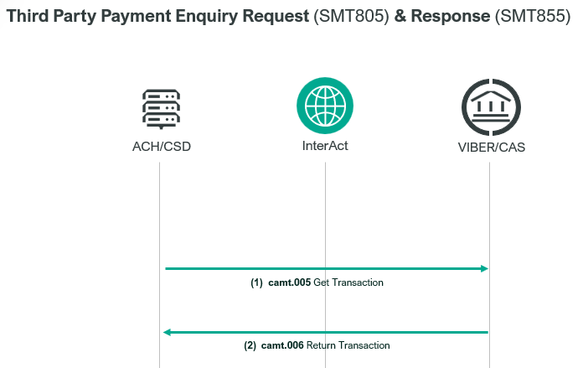
A direct participant may use a camt.005.001.08 message to query their sent but as yet unsettled payment orders of a given status (queued, awaiting start of settlement, awaiting new CAS date of execution). CAS responds with a camt.006001.08 message to the enquiry.
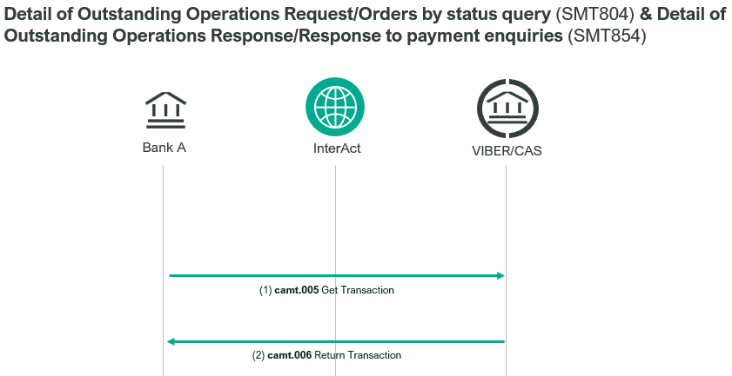
KELER and GIRO Zrt. can use a camt.005.001.08 SWIFT message to query the status of its settlement and instant internal transfer orders in CAS. Only single transaction orders can be queried.

- Element specification
The below table includes the SWIFT format specification.
M/O | Element | 800 | 804 | 805 | MX options | MT equivalent field | MT equivalent field name
M | AppHdr/Fr/FIId/FinInstnId/BICFI | X | X | X | CAS settlement BIC | n/a
M | AppHdr/To/FIId/FinInstnId/BICFI | X | X | X | receiving BIC (MANEHU2AXXX) | n/a
M | AppHdr/BizMsgIdr | X | X | X | Business Message Identifier | n/a
M | AppHdr/MsgDefIdr | X | X | X | camt.005.001.08 | n/a
M | AppHdr/BizSvc | X | X | X | swift.iap.01 | n/a
M | AppHdr/CreDt | X | X | X | Creation Date and Time | n/a
M | Document/GetTx/MsgHdr/MsgId | X | X | X | Message Identification | 20 | Transaction Reference Number
M | Document/GetTx/MsgHdr/ReqTp/Prtry/Id | X | X | X | Request Type: 800/804/805 | 12 | Sub-Message Type
O | Document/GetTx/TxQryDef/  TxCrit/NewCrit/SchCrit/PmtFr/MmbId/FinInstnId/BICFI |  | X | X | Payment From Member ID | L04  L02 | CAS Member BIC  Originator BIC
O | Document/GetTx/TxQryDef/  TxCrit/NewCrit/SchCrit/PmtSch/MsgId | X |  | X | Related Message Identification | L02 | Transaction Reference Number
O | Document/GetTx/TxQryDef/  TxCrit/NewCrit/SchCrit/PmtSch/Sts/PrtryStsRsn |  | X |  | Payment Status (WTFD,PNDG,WHSD) | L01 | CAS Object State
O | Document/GetTx/TxQryDef/  TxCrit/NewCrit/SchCrit/PmtSch/CdtDbtInd | X |  |  | Related Credit/Debit Indicator  (CRDTor DBIT) | L02 | Credit/Debit Indicator
O | Document/GetTx/TxQryDef/  TxCrit/NewCrit/SchCrit/PmtSch/PmtTp/Prtry | X |  | X | Related Payment Type | L02 | Message Type and  Sub-message Type
O | Document/GetTx/TxQryDef/  TxCrit/NewCrit/SchCrit/PmtSch/IntrBkSttlmDt | X |  | X | Related Settlement Date | L02 | Value date
O | Document//GetTx/TxQryDef/TxCrit/NewCrit/  SchCrit/PmtSch/Pties/DbtrAgt/FinInstnId/BICFI† | X |  |  | Debtor Agent BIC | L02 | CAS Member BIC

- Format specification
Document/GetTx/MsgHdr/ReqTp/Prtry/Id - Request Type
It is a mandatory element used for indicating the type of request for notification. Request Type can be:
- 800: in case of settled payment enquiry
- 804: in case of outstanding payment enquiry
- 805: in case of third party payment enquiry
Document/GetTx/TxQryDef/TxCrit/NewCrit/SchCrit/PmtFr/MmbId/FinInstnId/BICFI† - Payment From Member Id
tag includes the BIC code of the direct participant sending the camt.005.001.08 message. Mandatory, if the Request Type is 804 or 805.
Document/GetTx/TxQryDef/TxCrit/NewCrit/SchCrit/PmtSch/MsgId - Related Message Identification
tag includes the Message Identification of the related payment. Mandatory, if the Request Type is 800 or 805.
Document/GetTx/TxQryDef/TxCrit/NewCrit/SchCrit/PmtSch/Sts/PrtryStsRsn - Payment Status
tag indicates the status of the payment order that the direct participant wishes to query. According to the status, which is the subject of the query the orders can be described as follows:
- WTFD/ready = payment is queued for settlement;
- PNDG/pending = payment is awaiting the start of settlement;
- WHSD/warehoused = payment is pending new CAS date of execution.
If the field is not present, then WTFD is assumed.
Mandatory, if the Request Type is 804.
Document/GetTx/TxQryDef/TxCrit/NewCrit/SchCrit/PmtSch/CdtDbtInd - Credit/Debit Indicator
If it is a Message Type 800, then it is a mandatory element in which the participant can indicate if the request is related to the debit or credit orders in their favour.
Document/GetTx/TxQryDef/TxCrit/NewCrit/SchCrit/PmtSch/PmtTp/Prtry - Related Payment Type
In case of the Message Type is 800 or 805 it is a mandatory element which indicates the payment type of the related transaction according to the former MT format (message type/sub-message type) concatenated, separated by “//”.

Document//GetTx/TxQryDef/TxCrit/NewCrit/SchCrit/PmtSch/Pties/DbtrAgt/FinInstnId/BICFI† - Debtor Agent BIC
Mandatory, if the Request Type is 800. It includes the submitter of the camt.005.001.08 message.
- Examples
- OTP Bank is querying the status of their pacs.008.001.08 message sent on 12-10-2023, using an Camt.005 (Request Type: 800) message. The Message Identifier of the pacs.008.001.08 message was CP9910121005.
https://www.mnb.hu/letoltes/camt-005-001-08-1-viber.txt
- UniCredit Bank queries its queued payment orders by sending a camt.005.001.08 (Request Type: 804) SWIFT message for 18.10.2021.
https://www.mnb.hu/letoltes/camt-005-001-08-2-viber.txt
- KELER queries about a settlement order that they sent with the reference number S230805010010KELRHUHBXXXDVP/2.
https://www.mnb.hu/letoltes/camt-005-001-08-3-viber.txt
- GIRO Zrt. makes a query about settlement order reference no. S231228010010GHUNHUHBGIRIG2CCOLL/1 submitted by it.
https://www.mnb.hu/letoltes/camt-005-001-08-4-viber.txt

