Camt.006.001.08 Return Transaction (MT equivalent: Mt298/SMT850 Payment Enquiry Response, MT298/SMT854 Detail of Outstanding Operations Response and MT298/SMT855 Third Party Payment Response)

Scope
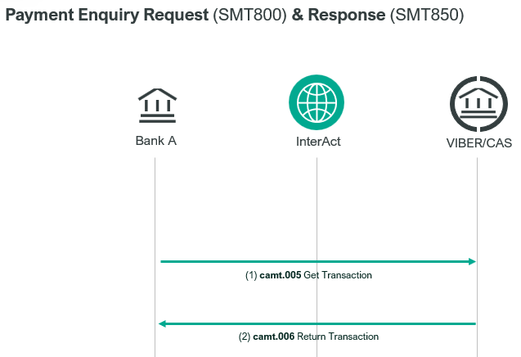
CAS responds to a camt.005.001.08 (Request Type: 800) Get Transaction message of a direct participant by sending a camt.006.001.08 (Query Name: 850) message.

CAS uses a camt.006.001.08 (Query Name: 854) message to respond to a direct participant’s camt.005.001.08 (Request Type: 804) message. The message includes all queued transaction orders of the requesting direct participant.
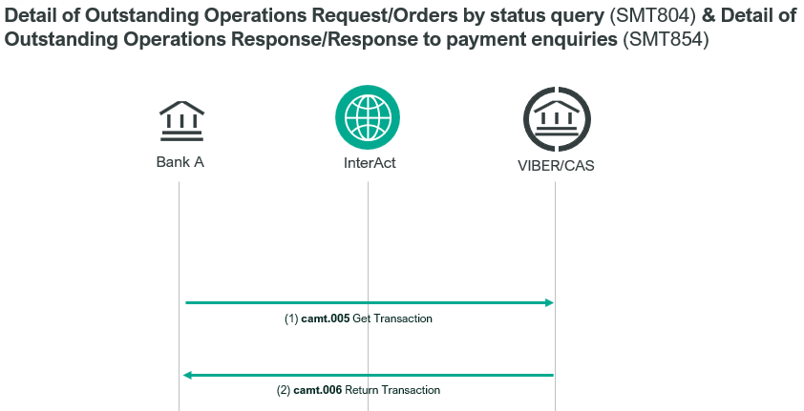

CAS responds to the query of KELER and GIRO Zrt. sent by a camt.005.001.08 (Request Type: 805) SWIFT message by a camt.006.001.08 (Query Name: 855) SWIFT message.

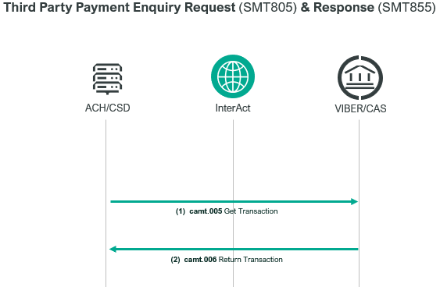

Element specification
The below table includes the SWIFT format specification.
M/O | Element | MX options | 850 | 854 | 855 | MT equivalent field | MT equivalent field name
M | AppHdr/Fr/FIId/FinInstnId/BICFI | CAS settlement BIC (MANEHU2AXXX) | X | X | X | n/a
M | AppHdr/To/FIId/FinInstnId/BICFI | receiving BIC | X | X | X | n/a
M | AppHdr/BizMsgIdr | Business Message Identifier | X | X | X | n/a
M | AppHdr/MsgDefIdr | camt.006.001.08 | X | X | X | n/a
M | AppHdr/BizSvc | swift.iap.01 | X | X | X | n/a
M | AppHdr/CreDt | Creation Date/Time | X | X | X | n/a
M | Document/RtrTx/MsgHdr/MsgId | Message Identification | X | X | X | 20 | TRN
M | Document/RtrTx/MsgHdr/CreDtTm | Creation Date And Time | X | X | X | L12 | Cas action time
M | Document/RtrTx/MsgHdr/MsgPgntn/PgNb | Page Number | X | X | X | L03 | Page number
M | Document/RtrTx/MsgHdr/MsgPgntn/LastPgInd | Last Page Indicator | X | X | X | n/a
O | Document/RtrTx/MsgHdr/OrgnlBizQry/MsgId | Original Message Identification | X | X |  | L02  L04  L01 | TRN  CAS Member BIC  CAS Object State
O | Document/RtrTx/MsgHdr/OrgnlBizQry/MsgNmId | Original Message Name  Identification | X |  |  | L02 | Credit/debit Indicator Value Date  Message type  Sub-message type
O | Document/RtrTx/MsgHdr/ReqTp/Prtry/Id | Request Type Identification | X |  |  | L02 | CAS Member BIC
M | Document/RtrTx/MsgHdr/QryNm | Query Name | X | X | X | 12 | Sub-Message Type
M | Document/RtrTx/RptOrErr/BizRpt/TxRpt/PmtId/TxId | Transaction Identification | X | X | X | 21 | Related reference
O | Document/RtrTx/RptOrErr/  BizRpt/TxRpt/TxOrErr/Tx/PmtTo/MmbId/FinInstnId/BICFI | Payment To BIC | X | X | X | L04  (second) | Credit BIC
O | Document/RtrTx/RptOrErr/  BizRpt/TxRpt/TxOrErr/Tx/PmtFr/MmbId/FinInstnId/BICFI | Payment From BIC | X |  | X | L04 (first) | Debit BIC
O | Document/RtrTx/RptOrErr/  BizRpt/TxRpt/TxOrErr/Tx/Pmt/Sts/DtTm/DtTm | Date and Time | X |  |  | 13 | CAS message Timestamp (debit only)
O | Document/RtrTx/RptOrErr/  BizRpt/TxRpt/TxOrErr/Tx/Pmt/Sts/Rsn/Prtry | Payment Status | X |  |  | L10  L07 | CAS Message Status  CAS Source Code
O | Document/RtrTx/RptOrErr/  BizRpt/TxRpt/TxOrErr/Tx/CdtDbtind | Credit/Debit Indicator |  | X |  | L02 | Credit/Debit Indicator
O | Document/RtrTx/RptOrErr/  BizRpt/TxRpt/TxOrErr/Tx/Pmt/MsgId | Payment Message Identification |  | X | X | L02 | TRN
O | Document/RtrTx/RptOrErr/  BizRpt/TxRpt/TxOrErr/Tx/Pmt/Sts/Cd/Prtry | Status Code |  |  | X | L01 | CAS Object State
O | Document/RtrTx/RptOrErr/  BizRpt/TxRpt/TxOrErr/Tx/Pmt/IntrBkSttlmAmt/AmtWthCcy | Amount With Currency | X | X | X | L02/32B | Amount and Currency
O | Document/RtrTx/RptOrErr/  BizRpt/TxRpt/TxOrErr/Tx/Pmt/PmtMtd/Prtry | Payment Method |  | X | X | L02 | Message Type  Sub-Message Type
O | Document/RtrTx/RptOrErr/  BizRpt/TxRpt/TxOrErr/Tx/Pmt/Prty/Prtry | Priority | X | X | X | 113 | Business Priority
O | Document/RtrTx/RptOrErr/  BizRpt/TxRpt/TxOrErr/Tx/Pmt/IntBkSttlmDt | Interbank Settlement Date |  | X | X | L02 | Value Date
O | Document/RtrTx/RptOrErr/  BizRpt/TxRpt/TxOrErr/Tx/Pmt/Pties/DbtrAgt/FinInstnId/BICFI | Debtor Agent BIC |  | X | X | L02  L02 | Submitter BIC  Third Party BIC
O | Document/RtrTx/RptOrErr/  BizRpt/TxRpt/TxOrErr/BizErr/Err/Prtry | Business Error | X | X | X | L05  n/a | CAS Action Response

Format specification
- Document/RtrTx/MsgHdr/OrgnlBizQry/MsgId – Original Message Identification
850: contains the Message Identification of the payment which the enquiry refers to.
854: contains
- the BIC code of the credit party indicated in the order and
- the payment status (WTFD, PNDG or WHSD).
- If payment status was not present in the request then it contains WTFD in this response.
Components are separated by „//”
e.g.: „OTPVHUHBXXX//WTFD”
- Document/RtrTx/MsgHdr/OrgnlBizQry/MsgNmId – Original Message Name Identification
850: contains the following details from the associated camt.005.001.08 - Payment Enquiry Request:
- Credit/Debit indicator (CRDT or DBIT)
- Settlement Date
- Message Definition Identifier, repeated; e.g. „008//008” in case of a pacs.008 message
Components are separated by „//”
e.g. “DBIT//2023-10-13//008//008”
- Document/RtrTx/MsgHdr/ReqTp/Prtry/Id – Request Type Identification
850: Contains submitter BIC from associated camt.005.001.08 message.
- Document/RtrTx/MsgHdr/QryNm – Query Name
contains the response type: 850, 854 or 855
- Document/RtrTx/RptOrErr/BizRpt/TxRpt/PmtId/TxId – Transaction Identification
contains the Message Identification of the related camt.005.001.08 message.
- Document/RtrTx/RptOrErr/BizRpt/TxRpt/TxOrErr/Tx/PmtTo/MmbId/FinInstnId/BICFI – Payment To Member BIC is only present if payment is debit.
- Document/RtrTx/RptOrErr/BizRpt/TxRpt/TxOrErr/Tx/PmtFr/MmbId/FinInstnId/BICFI - Payment From Member BIC is only present if payment is credit. (In 854 it is not present.)
- Document/RtrTx/RptOrErr/BizRpt/TxRpt/TxOrErr/Tx/Pmt/Sts/DtTm/DtTm – Date and Time
850: Only present if the debit payment has been settled or refused or cancelled. This element contains the date and time when the status of the queried transaction order changed to the status indicated in Document/RtrTx/RptOrErr/BizRpt/TxRpt/TxOrErr/Tx/Pmt/Sts/Rsn/Prtry element.
- Document/RtrTx/RptOrErr/BizRpt/TxRpt/TxOrErr/Tx/Pmt/Sts/Rsn/Prtry – Payment Status
850: contains the following components:
- CAS message status that indicates the status of the queried order at the time when the camt.005.001.08 message was received by CAS. The most frequent status codes:
LN00 | Order has been settled
LT00 | Order is awaiting settlement
LF00 | Invalid message contents
LF01 | Invalid BIC code
LF02 | Invalid code_word
LF03 | Message contains incompatible field
LA70 | Rejected due to validation error
LA71 | Rejected because sender or receiver direct participant is unknown
LA72 | Order was already refused at the time of receipt or queuing due to late submission
LA73 | Refused due to unacceptable date of execution
LA74 | Refused because submitted order type is not permitted
LA75 | Not used
LA76 | Refused because direct participant has been suspended (default status)
LA77 | Duplicate message
LA78 | Invalid message
LA79 | Order has already been cancelled
LA80 | Failure in CAS operation
LA81 | Invalid message format
LA82 | Order cannot be completed due to insufficient cover and has been refused (the VIBER does not permit the sender of the given message to queue their transaction orders if there is no sufficient cover).
LA83 | The amount of the order is smaller than the minimum amount expected for this message type
LA84 | Not the appropriate account to be debited
- CAS source code indicates who gave the instruction to effect these changes in the status. Its format is as per former MT field L07 and present if CAS message status indicates that the payment has been rejected or cancelled. It will never be present in responses to credit enquiries.
Most frequent values are:
• LS000 = CAS sent the message resulting in a change of status
• LS001 = the message that resulted in a change of status was sent from a user interface at MNB
• LS002 = the message resulting in a change of status was sent by the direct participant
Components are separated by //, e.g. “LA79//LS002” or “LA79”.
- Document/RtrTx/RptOrErr/BizRpt/TxRpt/TxOrErr/Tx/CdtDbtind – Credit/Debit Indicator
854: fix value: „DBIT”
- Document/RtrTx/RptOrErr/BizRpt/TxRpt/TxOrErr/Tx/Pmt/MsgId – Payment Message Identification
854,855: contains the Message Identification of the related transaction.
- Document/RtrTx/RptOrErr/BizRpt/TxRpt/TxOrErr/Tx/Pmt/Sts/Cd/Prtry – Status Code
855: indicates the status of the order that the direct participant queried. According to the status, which is the subject of the query the orders can be described as follows:
• SETTLED = settlement is complete;
• REJECTED = CAS rejected the transaction order;
• CANCELLED = cancelled by KELER, GIRO or MNB.
- Document/RtrTx/RptOrErr/BizRpt/TxRpt/TxOrErr/Tx/Pmt/PmtMtd/Prtry – Payment Method
854, 855: Message Definition Identifier of the related transaction, repeated
e.g. „008//008” in case of a pacs.008.001.08 message
- Document/RtrTx/RptOrErr/BizRpt/TxRpt/TxOrErr/Tx/Pmt/Prty/Prtry - Priority
850: Business priority (numeric) is included in a camt.006.001.08 SWIFT message if CAS message status indicates that the queried payment is awaiting settlement and execution in CAS.
854: Original priority included in brackets after current, if different from current, e.g. “0095 (0098)” or “0095”.
- Document/RtrTx/RptOrErr/BizRpt/TxRpt/TxOrErr/BizErr/Err/Prtry – Business Error
850: „no payment found” Only present if no payments being reported.
Repeating tags:
One instance of BizRpt/TxRpt for each payment being reported.
If more than 50 payments are being reported, then a separate camt.006.001.08 (each with unique MsgId) is sent for each batch of 50 payments. The page number and last page indicator tags can be used to identify all messages that are part of the same response.
In case where no payments are being reported,
- 850: one instance of BizRpt/TxRpt containing only PmtId/TxId, and TxOrErr/BizErr/Err/Prtry.
- 854, 855: Document/RtrTx/RptOrErr tag contains one instance of BizRpt/TxRpt containing just:
- PmtId/TxId - as above
- TxOrErr/BizErr/Err/Prtry - “no payment found”

Examples
- OTP Bank querying the status of a payment order submitted on 28-12-2023 via pacs.008.001.08 message using a camt.005.001.08 (Request Type: 800) SWIFT message (Message Identification is: LT9910121015). The Message Identification of the pacs.008.001.08 message is CP9910121005, and the beneficiary of the message was UniCredit Bank. CAS responses in a camt.006.001.08 SWIFT message (Query Name: 850) that the given payment order was refused due to the fact that UniCredit Bank was locked out from the system on that day (defaulted) – Cas message status is LA76 –, and the lock-out was initiated by CAS (CAS source code is LS000).
https://www.mnb.hu/letoltes/camt-006-001-08-1-viber.txt
- OTP Bank querying the status of a payment order submitted on 28-12-2023 via pacs.008.001.08 message using a camt.005.001.08 (Request Type: 800) SWIFT message (Message Identification is: LT9910121015). The Message Identification of the pacs.008.001.08 message is CP9910121005, and the beneficiary of the message was UniCredit Bank. CAS responses in a camt.006.001.08 SWIFT message (Query Name: 850) that the payment order couldn’t found.
https://www.mnb.hu/letoltes/camt-006-001-08-2-viber.txt
- OTP Bank queries their queued messages (WTFD) by sending a camt.005.001.08 (Request Type: 804) (Message Identification: DR9910121016) with regard to settlement date 12-10-2023. CAS replied with the following camt.006.001.08 message (Query Name: 854), indicating that the direct participant has 2 queued messages.
https://www.mnb.hu/letoltes/camt-006-001-08-3-viber.txt
- OTP Bank queries their queued messages (WTFD) by sending a camt.005.001.08 (Request Type: 804) (Message Identification: DR9910121016) with regard to settlement date 12-10-2023. CAS replied with the following camt.006.001.08 message (Query Name: 854), indicating that no payment was found.
https://www.mnb.hu/letoltes/camt-006-001-08-4-viber.txt
- CAS responses with the following camt.006.001.08 (Query Name: 855) SWIFT message to a camt.005.001.08 (Request Type: 805) SWIFT message with Message Identification LEKERDEZES/1 sent by KELER.
https://www.mnb.hu/letoltes/camt-006-001-08-5-viber.txt
- CAS sends the following camt.006.001.08 (Query Name: 855) message in response to GIRO Zrt.’s LEKERDEZES/1 Message Identification camt.005.001.08 (Request Type: 805) message:
https://www.mnb.hu/letoltes/camt-006-001-08-6-viber.txt

