Camt.007.001.08 – Modify Transaction (mt equivalent: mt298/SMT 202 payment priority change)

Scope
A direct participant can change the priority of a sent message that has not been processed yet by sending a camt.007.001.08 message. There is no response message if the change of priority was successful. If CAS is unable to change the priority, then the direct participant will receive a camt.025.001.05 message.

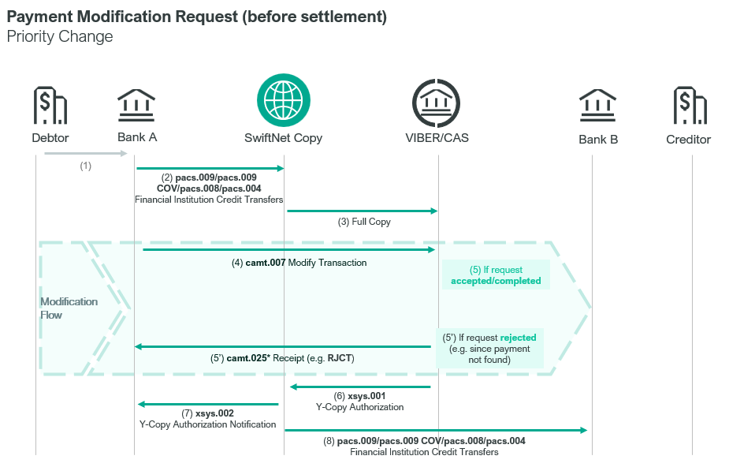

Element specification
The below table includes the SWIFT format specification.
M/O | Element | Options | MT equivalent field | MT equivalent field name
M | AppHdr/ Fr/FIId/FinInstnId/BICFI | CAS settlement BIC | n/a
M | AppHdr/ To/FIId/FinInstnId/BICFI | receiving BIC (MANEHU2AXXX) | n/a
M | AppHdr/ BizMsgIdr | Business Message Identifier | n/a
M | AppHdr/ MsgDefIdr | admi.004.001.02 | n/a
M | AppHdr/ BizSvc | swift.iap.01 | n/a
M | AppHdr/ CreDt | Creation Date and Time | n/a
M | Document/ModfyTx/MsgHdr/MsgId | Message Identification | 20 | Transaction Reference Number
M | Document/ModfyTx/Mod/PmtId/LngBizId/TxId | Transaction Identification | L02 | Related Reference Number
M | Document/ModfyTx/Mod/PmtId/LngBizId/UETR | UETR | n/a
M | Document/ModfyTx/Mod/PmtId/LngBizId/IntrBkSttlmAmt | Amount and Currency | L02 | CAS Message Details
M | Document/ModfyTx/Mod/PmtId/LngBizId/IntrBkSttlmDt | Settlement Date | L02 | Value Date
M | Document/ModfyTx/Mod/PmtId/LngBizId/PmtMtd/Prtry | Payment Method | L02 | Message Type  Sub-message Type
M | Document/ModfyTx/Mod/PmtId/LngBizId/InstgAgt/FinInstnId | Instructing Agent | L02 | Submitter BIC
M | Document/ModfyTx/Mod/PmtId/LngBizId/InstdAgt/FinInstnId | Instructed Agent | n/a
M | Document/ModfyTx/Mod/NewPmtValSet/Prty/Prtry | New Payment Value Set | 113 | Business Priority

Format specification
- Document/ModfyTx/Mod/PmtId/LngBizId/TxId element contains the Message Identifier of the original transaction for which the priority change is required.
- Document/ModfyTx/Mod/PmtId/LngBizId/UETR element contains the UETR of the original transaction.
- Document/ModfyTx/Mod/PmtId/LngBizId/PmtMtd/Prtry element contains the former MT field L02 message type and sub-message type of the original transaction concatenated, separated by “//”:
  - 3x = message type, e.g. “008” (in case of a pacs.008.001.08 messsage)
  - 3x=message subtype. If this message does not have a subtype, then it contains the same value as that of the message type. e.g. “008//008”
- Document/ModfyTx/Mod/NewPmtValSet/Prty/Prtry element contains the new priority for the payment as a numeric value.

Example
- OTP Bank wants to change the priority of its pacs.009.001.08 message (TRN code: BT991012004, sent on 12-10-2023 from 12 to 15.
https://www.mnb.hu/letoltes/camt-007-001-08-1-viber.txt

