camt.008.001.08 – Cancel Transaction (MT equivalent: SMT200 – Payment cancellation)

Scope
A direct participant sends a camt.008.001.08 message to request cancellation of a transaction order that was sent by them but has not been settled yet. CAS returns an xsys.003 message to the sender of the transaction order as a confirmation of cancellation. The credit party is notified of the successful cancellation via a pacs.002.001.10 message. If the cancellation request is rejected, the sender of the camt.008.001.08 message receives a camt.025.001.05 message.
The camt.008.001.08 cancellation order will only be executed if the message to be cancelled has been received in VIBER and the conditions for cancellation (time elapsed, queuing due to lack of coverage) exist.
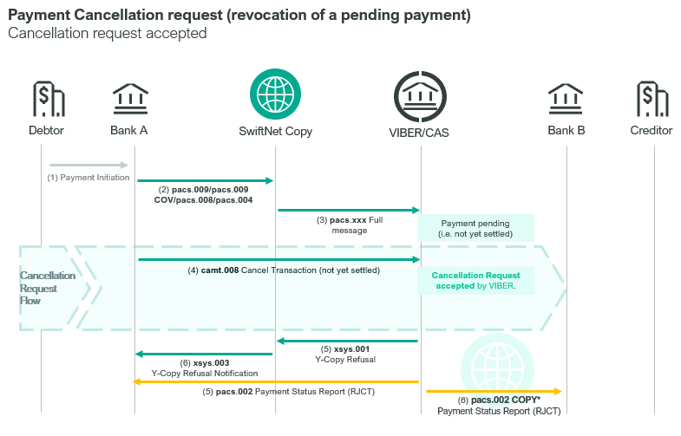

In response to a payment and settlement order by KELER and GIRO Zrt. (pacs.010.001.03) CAS sends a pacs.002.01.10 message if the order has been cancelled. The recipients of the pacs.002.01.10 message are KELER/GIRO Zrt. as financial infrastructure and the debit and credit parties.
Cancellation of a settlement order initiated by KELER may only be submitted to VIBER by KELER. In the case of settlement orders connected to the ICS multiple intraday clearing submitted by GIRO Zrt, the cancellation may only be initiated by GIRO Zrt.

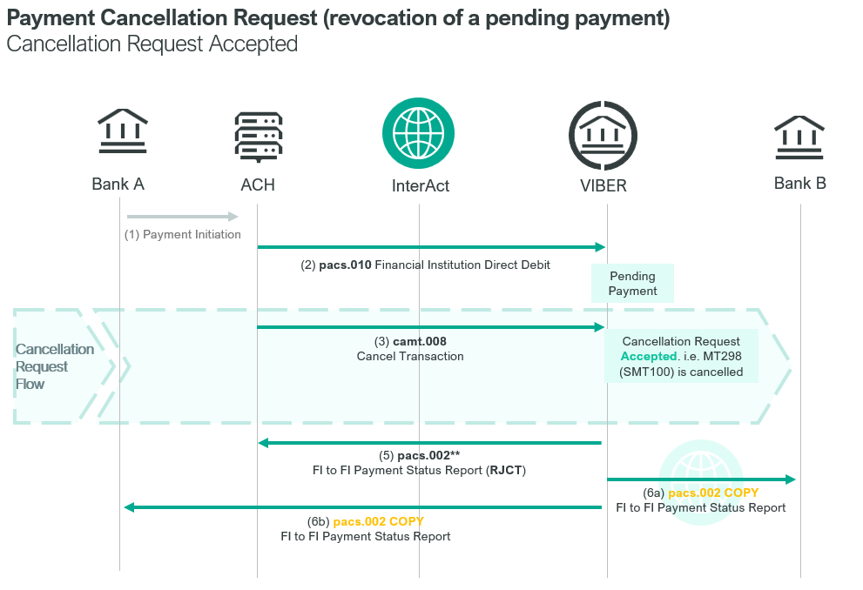

Element specification
The below table includes the SWIFT format specification.
M/O | Element | MX options | MT equivalent field | MT equivalent field name
M | AppHdr/Fr/FIId/FinInstnId/BICFI | sender BIC | n/a
M | AppHdr/To/FIId/FinInstnId/BICFI | receiving BIC (MANEHU2AXXX) | n/a
M | AppHdr/BizMsgIdr | Business Message Identifier | n/a
M | AppHdr/MsgDefIdr | camt.008.001.08 | n/a
M | AppHdr/BizSvc | swift.iap.01 | n/a
M | AppHdr/CreDt | Creation Date and Time | n/a
M | Document/CclTx/MsgHdr/MsgId | Message Identification | 20 | Transaction Reference Number
M | Document/CclTx/MsgHdr/ReqTp/Prtry/Id | Request Type | L02 | CAS Message Details -  message type//sub-message type
M | Document/CclTx/PmtId/LngBizId/TxId | Message Identification | L02 | CAS Message Details - TRN
M | Document/CclTx/PmtId/LngBizId/UETR | UETR | n/a
M | Document/CclTx/PmtId/LngBizId/IntrBkSttlmAmt | Amount | n/a
M | Document/CclTx/PmtId/LngBizId/IntrBkSttlmDt | Settlement Date | L02 | CAS Message Details – Value Date
M | Document/CclTx/PmtId/LngBizId/InstgAgt/FinInstnId | Instructing Agent BIC | L02 | CAS Message Details - Submitter BIC
M | Document/CclTx/PmtId/LngBizId/InstdAgt/FinInstnId | Instructed Agent (MANEHU2AXXX) | n/a

Format specification
- Document/CclTx/MsgHdr/ReqTp/Prtry/Id contains the message type and the message subtype of the original transaction for which cancellation is requested, concatenated, separated with //
• 3x = message type, e.g. 008 (pacs.008)
• 3x = message subtype (MT). If this message does not have a subtype, then it contains the same value as that of the message type.
e.g. 008//008 (pacs.008)
If the transaction is an account transfer the message type will be TRF, just like the message subtype.
e.g. TRF//TRF
- Document/Payment Identification elements identify the transaction order to be cancelled (original transaction).
- Message Identification of the original message,
- UETR of the original message
- Amount
- Settlement Date
- Instructing Agent BIC
- Instructed Agent: MANEHU2AXXX

Example
- OTP Bank wishes to cancel the pacs.008 message identified with TRN code CT991012003 sent on the value date of 18-10-2023.
https://www.mnb.hu/letoltes/camt-008-001-08-1-viber.txt
- OTP Bank buys securities from ING for 10 million HUF. KELER sent an SMT 100 SWIFT message requesting the settlement of this transaction in VIBER. Later, on the request of KELER, a cancellation request of type SMT 200 SWIFT was submitted to VIBER for the same transaction order.
https://www.mnb.hu/letoltes/camt-008-001-08-2-viber.txt
- GIRO Zrt. requested in an SMT 100 message the settlement of ICS multiple intraday clearing in VIBER. Later GIRO Zrt. submitted an SMT 200 cancellation order in VIBER in respect of this settlement order. (30M)
https://www.mnb.hu/letoltes/camt-008-001-08-3-viber.txt

