Camt.011.001.07 – MODIFY LIMIT (MT EQUIVALENT: SMT 600 – Collateral Change)

Scope
MNB does not provide intraday collaterals for payment institutions, their requests for collateral change only affect the instant collateral. Money-market clients cannot give declarations regarding the instant collateral, they can increase or decrease their intraday collateral only.
In response to a direct participant’s request for intraday/instant collateral change KELER sends a camt.011.001.07 message to CAS, to the MNB’s client account management system in the case of instant collateral change, requesting the change of the direct participant’s intraday/instant collateral. MNB uses the same message type to notify KELER about the acceptance or refusal of the request for intraday/instant collateral change.
It is also the camt.011.001.07 message that can be used to provide a security deposit, blocked with MNB as the beneficiary, as a security for bank card settlements, and to release it.
Collateral call
When, during collateral valuation, the customer of MNB becomes underhedged (is at the minimum balance) and the customer does not respond until the given deadline or unable to pay back the one-day collateralised loan then MNB may request from KELER to unblock the full security portfolio used as collateral for the intraday/instant credit line of the direct participant, and to recall the securities at the same time (crediting them to the securities account of MNB). MNB sends a camt.011.001.07 message to KELER, requesting the completion of the recall. The security portfolio will be transferred from the given direct participant to the security account of MNB. KELER does not send confirmation of the release of blocked intraday/instant credit and collateral to MNB.
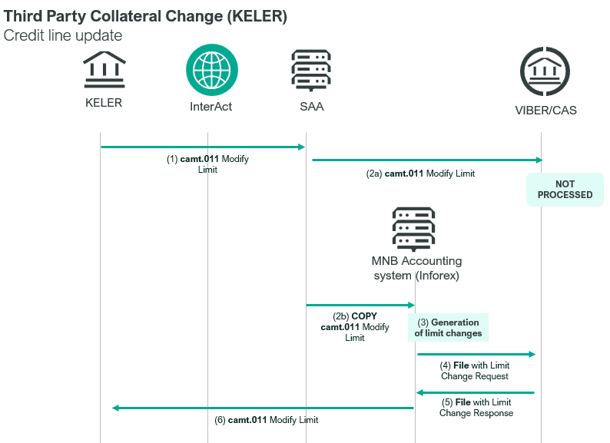

Element specification
The below table includes the SWIFT format specification.
M/O | Element | MX options | MT equivalent field | MT equivalent field name
M | AppHdr/Fr/FIId/FinInstnId/BICFI | sender BIC | n/a
M | AppHdr/To/FIId/FinInstnId/BICFI | receiving BIC (MANEHU2AXXX) | n/a
M | AppHdr/BizMsgIdr | Business Message Identifier | n/a
M | AppHdr/MsgDefIdr | camt.011.001.07 | n/a
O | AppHdr/BizSvc | swift.base.01 | n/a
M | AppHdr/CreDt | Creation Date and Time | 32N | Currency Code, Amount
M | Document/ModfyLmt/MsgHdr/MsgId | Message Identification | 20 | Transaction Reference Number
M | Document/ModfyLmt/LmtDtls/LmtId/Cur/BilLmtCtrPtyId/FinInstnId/BICFI† | FI Identification (BIC) | L04 | CAS Member BIC
M | Document/ModfyLmt/LmtDtls/LmtId/Cur/Tp/Prtry | fixed value: COLL | n/a
M | Document/ModfyLmt/LmtDtls/NewLmtValSet/StartDtTm/Dt | New Limit Value Date | 32N | Value Date
M | Document/ModfyLmt/LmtDtls/NewLmtValSet/Amt/AmtWithCcy | New Limit Amount and Currency | 32N | Amount and Currency
M | Document/ModfyLmt/LmtDtls/NewLmtValSet/CdtDbtInd | Credit Debit Indicator  (CRDT or DBIT) | 32N | Credit/Debit Indicator
O | Document/ModfyLmt/SplmtryData/PlcAndNm | Supplementary Data (R=rejected) | 32N | Credit/Debit Indicator
M | Document/ModfyLmt/SplmtryData/Envlp/SndrRcvrInfo | Sender to Receiver Information | 72 | Sender to Receiver Information

Format specification
- Document/ModfyLmt/LmtDtls/LmtId/Cur/BilLmtCtrPtyId/FinInstnId/BICFI†
The element contains the BIC code of the direct participant requesting the change of the intraday/instant credit or the collateral. MNB uses this element for the BIC code of the direct participant whose collateral for its full limit or security deposit is requested to be recalled.
- Document/ModfyLmt/LmtDtls/NewLmtValSet/StartDtTm/Dt
Date of execution should always be the same as the date of sending the message.
- Document/ModfyLmt/LmtDtls/NewLmtValSet/Amt/AmtWithCcy
Currency code is the currency in which the securities are denominated. The amount shows the securities nominal value, if other than collateral call.
For collateral recall the amount is always ‘999’.
- Document/ModfyLmt/LmtDtls/NewLmtValSet/CdtDbtInd
If this element is populated with “DBIT” then this amount is negative, which means that the KELER is requesting the reduction of the intraday/instant credit line or security deposit, or MNB responds to an intraday/instant credit or security deposit reduction request.
If this element is populated with “CRDT” then the amount is positive, and KELER is requesting the increase of the intraday/instant credit line or security deposit, or MNB responds to a request for intraday/instant credit or security deposit increase.
- Document/ModfyLmt/SplmtryData/PlcAndNm
If MNB does not authorise the change in the intraday/instant credit line or security deposit, then this element will be populated with “R” and the amount will be the same as the original amount in the request for changing the intraday/instant credit line or security deposit.
- Document/ModfyLmt/SplmtryData/Envlp/SndrRcvrInfo
This element must be populated according to the filed 72 of the former MT298/SMT600 message. Line breaks are indicated wit “::”.
Change in the intraday credit line
KELER enters the ISIN code of the security affected by the change of intraday credit line:
- The first line contains /X/.
- The second line contains the ISIN/codeword, followed by the ISIN code of the security involved in the change of the intraday credit line.
  - ISIN: 2a10n (country code, number), which should be followed by a comma.
E.g.: <SndrRcvrInfo>/X/.::/ISIN/HU1234567890,</SndrRcvrInfo>

Instant collateral change
In its message sent to MNB, KELER will indicate the ISIN code of the security involved in the instant collateral change:
- The first line is the codeword of the instant collateral, /AFRLIMIT/, between two “/” characters.
- The second line contains the /ISIN/ codeword and is followed by the ISIN code of the security involved in the instant collateral change.
  - ISIN: 2a10n (country code, number), which should be followed by a comma.
E.g.: <SndrRcvrInfo>/AFRLIMIT/.::/ISIN/HU1234567890,</SndrRcvrInfo>
Changing the bank card security deposit
KELER enters the block group, block expiration, non-VIBER bank code, ISIN code, nominal value, and number of the security of the bank blocking the security:
- The first line contains the codeword of the card issuer between two ‘/’ symbols, followed by the end of the period of blocking: YYYY.MM.DD; Codewords: VISACARD; MASTCARD
- In the second line “.” character will be included after the // symbol.
- The third and fourth lines are the same as those described at the changing of limits.
- In the fifth line the codeword /DARAB/ is followed by the number of blocked securities.
E.g.:<SndrRcvrInfo>/VISACARD/2021.10.29:://.::/ISIN/HU0000111222,::/VALUE/HUF8000000,::/DARAB/800</SndrRcvrInfo>
Enforcement of collateral
The codeword related to enforcement of collateral will be entered by MNB into this element, along with the account and sub-account numbers with KELER, which is the target of the transfer of enforced collateral.
- The first line includes the key word /ELVONAS/.
- The second line contains the primary account of MNB opened with KELER after the // symbol, with a length of 4n. E.g.: //0021
- The third line contains the sub-account of MNB opened with KELER after the // symbol, with a length of 6n. E.g.: //000000
- By entering the code_words /VIBER/; /AFRLIMIT/; /VISACARD/ or /MASTCARD/ in the fourth line MNB indicates which blocked securities they intend to recall due to an underhedged portfolio (to release the blocking of the full securities portfolio including the blocked group, and to recall the securities by transferring them to the securities account of MNB).
E.g.: <SndrRcvrInfo>/ELVONAS/.:://0021:://000000::/VIBER</SndrRcvrInfo>

Examples
Change in the intraday credit line
1.a) ING Bank advises KELER of an increase of the intraday credit line. KELER blocked securities of a nominal value of 10,000,000 HUF on the securities account of the bank, as required for the increase of intraday credit. KELER sends the following camt.011.001.07 message about the change in the intraday credit line.
mnb.hu/letoltes/camt-011-001-07-1a-viber.txt
1.b) In response to the request of KELER for a decrease of intraday credit MNB sends a camt.011.001.07 message to KELER, indicating that the request from OTP Bank for a reduction of the intraday credit line by a nominal value of 10 million HUF has been accepted.
mnb.hu/letoltes/camt-011-001-07-1b-viber.txt
2.a) ING Bank sends a request to KELER for a decrease of the intraday credit line. KELER sends the following camt.011.001.07 message to CAS about the change in the intraday credit line.
mnb.hu/letoltes/camt-011-001-07-2a-viber.txt
2.b) In response to the request of KELER for an decrease of the intraday credit line MNB sends a camt.011.001.07 message to KELER, indicating that the request from ING Bank for a reduction of the intraday credit line by a nominal value of 10 million HUF has been refused.
mnb.hu/letoltes/camt-011-001-07-2b-viber.txt
Changing the bank card security deposit
3. ING Bank reported the blocking of securities to KELER in order to effect an increase of the VISA security deposit. KELER blocked securities valued at 8 million HUF on the securities account of the bank, as required for the increase of the security deposit. KELER sends the following camt.011.007.01 message to CAS about the change in security deposit.
mnb.hu/letoltes/camt-011-001-07-3-viber.txt
4.a) OTP Bank notified KELER of the release of blocked securities in order to effect a reduction of the VISA security deposit by 2 million HUF. KELER sends the following camt.011.007.01 message to CAS about the reduction of the security deposit.
mnb.hu/letoltes/camt-011-001-07-4a-viber.txt
4.b) In response to the request of KELER for an decrease of the security deposit MNB sends a camt.011.007.01 message to KELER indicating that the request of OTP Bank for a reduction of the security deposit by 2 million HUF has been refused.
mnb.hu/letoltes/camt-011-001-07-4b-viber.txt

Instant collateral change
5.a) O.F.SZ. announced an increase of the collateral to KELER. KELER blocked the securities having a nominal value of HUF 10,000,000 on the securities deposit account of the payment institution as necessary for the increasing of the collateral. KELER sends the following camt.011.007.01 message to MNB regarding the change of the instant collateral.
mnb.hu/letoltes/camt-011-001-07-5a-viber.txt
5.b) At the request of KELER to reduce an instant collateral, MNB sent a camt.011.007.01 message to KELER, indicating that it has approved of the reduction of the collateral of O.F.SZ., in a nominal value of HUF 10,000,000.
mnb.hu/letoltes/camt-011-001-07-5b-viber.txt
6.a) O.F.SZ. sent a request for the reduction of its instant collateral. KELER sends the following camt.011.007.01 message to MNB regarding the change of the instant collateral.
mnb.hu/letoltes/camt-011-001-07-6a-viber.txt
6.b) At the request of KELER to reduce an instant collateral, MNB sent a camt.011.007.01 message to KELER, informing it that it does not accept the reduction of the instant collateral in the nominal amount of HUF 10,000,000 for O.F.SZ.
mnb.hu/letoltes/camt-011-001-07-6b-viber.txt
Collateral call
7. MNB initiates the recall of the collateral for the full intraday credit line of ING Bank.
mnb.hu/letoltes/camt-011-001-07-7-viber.txt

