camt.025.001.05 Liquidity Transfer Receipt (MT equivalent: MT298/SMT250 – Payment Cancellation Refusal Response and MT298/SMT252 Payment Priority Change Refusal Notification)

Scope
If CAS is unable to perform the cancellation request (camt.008.001.08) of a direct participant, it will send a camt.025.001.05 message in response. The message will also include the reason for refusal.
CAS responds to the cancellation request of type camt.008.001.08 SWIFT message from KELER and GIRO Zrt. with a camt.025.001.05 SWIFT message if it is unable to cancel the settlement and payment order. In its response CAS also indicates the reason for the refusal.
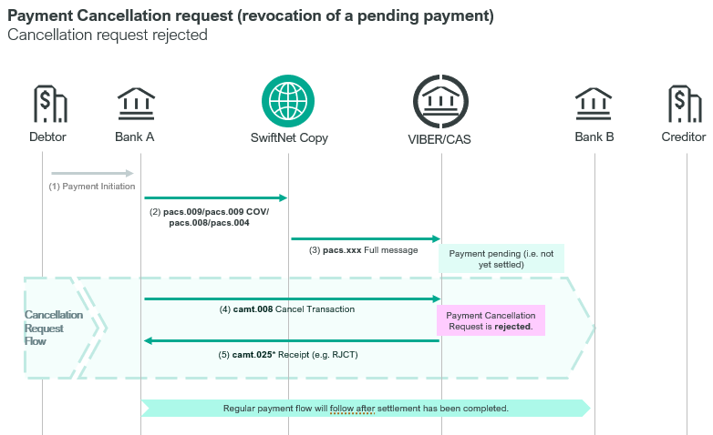

If CAS is unable to perform the priority change request of a direct participant, it will send a camt.008.001.08 message, indicating the reason for refusal.
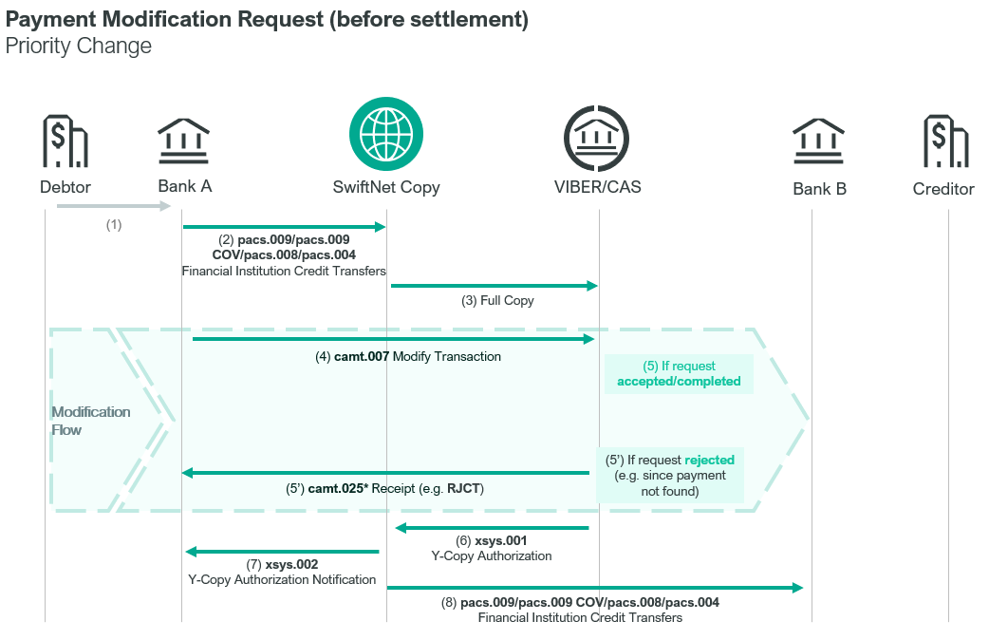

Element specification
The below table includes the SWIFT format specification.
M/O | Element | MX options | MT equivalent field | MT equivalent field name
M | AppHdr/Fr/FIId/FinInstnId/BICFI | Sender BIC (MANEHU2AXXX) | n/a
M | AppHdr/To/FIId/FinInstnId/BICFI | Receiving BIC | n/a
M | AppHdr/BizMsgIdr | Business Message Identifier | n/a
M | AppHdr/MsgDefIdr | camt.025.001.05 | n/a
M | AppHdr/BizSvc | swift.iap.01 | n/a
M | AppHdr/CreDt | Creation Date and Time | n/a
M | Document/Rct/MsgHdr/MsgId | Message Identifier | 20 | Transaction Reference Number
O | Document/Rct/MsgHdr/CreDtTm | Creation Date and Time | L12 | CAS action time
O | Document/Rct/MsgHdr/ReqTp/Prtry/Id | Request Type: “250” or “252” | 12 | Sub-Message Type
M | Document/Rct/RctDtls/OrgnlMsgId/MsgId | Original Message Identification | 21 | Related Reference
M | Document/Rct/RctDtls/ReqHdlg/StsCd | Status Code | L05 | CAS Action Response
O | Document/Rct/RctDtls/ReqHdlg/Desc | Description | L02  13  L10 | CAS Message Details  CAS Message Timestamp (optional)  CAS Message Status (optional)

Format specification
- Document/Rct/MsgHdr/ReqTp/Prtry/Id (Request Type) indicates the type of the response message:
250 – payment cancellation request is rejected, or
252 – payment priority change request is rejected
- Document/Rct/RctDtls/OrgnlMsgId/MsgId (Original Message Identification) has the same value as the Message Identification in the camt.008.001.08 or camt.007.001.08 message to which it responds.
- Document/Rct/RctDtls/ReqHdlg/StsCd (Status Code) contains the reason of refusal, which may be the following:
  - LR00 = The message, which was requested to be cancelled has already been settled, that is, the order has been completed / Priority change was not performed because the given message has already been settled successfully, that is, the order has been completed
  - LR01 = Because it failed to find the order to be cancelled, cancellation was not performed by CAS / Priority change cannot be completed because the given transaction order cannot be found
  - LR03 = Cancellation is not performed due to order status / Priority change cannot be performed due to order status.
- Document/Rct/RctDtls/ReqHdlg/Desc contains the following details; the components are concatenated with the former MT field tag, and separated by “//”
e.g. “L02 D231026008008BACXHUHBXXX4125630000981//13 9610281200//L10 LN00”
  - former MT L02 field: CAS message details, which identifies the payment for which cancellation/priority change was requested.
  - 1x = credit or debit order flag - C or D
  - 6n = value date of the original transaction: yymmdd, e.g. 231028
  - 3x = message type, e.g. 008
  - 3x = message subtype. If this message does not have a subtype, then it contains the same value as that of the message type. If the transaction is an account transfer the message type will be TRF, just like the message subtype.
  - 11a = 11-character long BIC code of the sender. E.g.: BACXHUHBXXX
  - 35x = Message Identifier of the message
  - former MT 13 field: CAS message timestamp contains the date and time when the status of the transaction order to be cancelled changed to the status indicated in CAS Message Status
  - former MT L10 field: CAS message status indicates the status of the order to be cancelled.

The most frequent status codes
LN00 | Payment has been settled
LT00 | Payment is awaiting settlement
LT01 | Payment is held
LF00 | Invalid message contents
LF01 | Invalid BIC code
LF02 | Invalid codeword
LF03 | Message contains unexpected field
LA70 | Rejected due to validation error
LA71 | Rejected because sender or receiver direct participant is unknown
LA72 | Aborted on entry or when queued and the settlement status for the payment type has been set to ‘closed’, ‘rejecting’ or ‘finished’ (i.e. CAS has stopped accepting or processing payments of this type)
LA73 | Refused due to invalid value date
LA74 | Refused because submitted payment order type is not permitted
LA75 | Not used
LA76 | Refused because direct participant has been suspended (default status)
LA77 | Duplicate message
LA78 | Invalid message
LA79 | Payment order has already been cancelled
LA80 | Failure in CAS operation
LA81 | Invalid message format
LA82 | Order cannot be completed due to insufficient cover and has been refused (the VIBER does not permit the sender of the given message to queue their transaction orders if there is no sufficient cover).
LA83 | The amount of the order is less than the minimum allowed amount for this message type
LA84 | Not the appropriate account to be debited
LA85 | Not the appropriate account to be credited
LA86 | Rejected by AML Filter
LA87 | Rejected by operator

Examples
- OTP Bank sent a camt.008.001.08 SWIFT message, indicating their intent to cancel the payment order submitted on 12-10-2023 in a pacs.008.001.08 message under Message Identifier 991012003. (The Message Identifier of the order is: T991012103.)
CAS refused the cancellation request at 11:10 AM as the payment order was already executed (right before the submission of the camt.008.001.08 SWIFT message at 11:00) on the same VIBER business day (12-10-2023).
https://www.mnb.hu/letoltes/camt-025-001-05-1-viber.txt
- The pacs.009.001.08 message sent by OTP Bank on 12-10-2023, requesting changing priority 12 to priority 15 was refused by CAS because the message could not be found (Document/Rct/RctDtls/ReqHdlg/StsCd : LR01). The Message Identifier of the sent message was: BT991012004.
https://www.mnb.hu/letoltes/camt-025-001-05-2-viber.txt
- OTP Bank concluded a security deal amounting to 10 million HUF with ING Bank, which was sent by KELER to VIBER for settlement and execution. On the request of OTP Bank KELER submitted a cancellation request in a camt.008.001.08 SWIFT message subsequently, which was refused by CAS with a camt.025.001.05 SWIFT message. The underlying reason for the rejection (LR03, LN00) was that the settlement order was already settled at 9:50.
https://www.mnb.hu/letoltes/camt-025-001-05-3-viber.txt
- GIRO Zrt. submitted a cancellation request in a camt.008.001.08 SWIFT message, which was refused by CAS with a camt.025.001.05 SWIFT message. The underlying reason for the rejection (LR03, LN00) was that the settlement order was already settled at 9:50.
https://www.mnb.hu/letoltes/camt-025-001-05-4-viber.txt

