camt.052.001.08 – Bank to Customer Account Report (MT equivalent: MT941 – Balance Report, MT942 Interim Transaction Report and MT298/SMT851 Summary of Outstanding Operations Response)

Scope
CAS sends information on the payment transactions executed to the credit of the direct participant.

Former – Balance Report
A direct participant can request a Balance Report in a camt.052 message from CAS by sending a camt.060.001.05 message. A camt.052.001.08 SWIFT message contains payment transactions (credited and debited) executed on the account of the querying direct participant on a given VIBER business day prior to the time of sending the message. No information is supplied about cancelled or refused payment transactions.
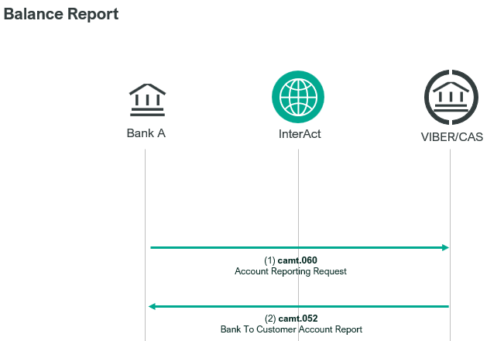

Former – Interim Transaction Report
In response to the camt.060.001.05 SWIFT message of the direct participant CAS sends a camt.052.001.08 SWIFT message, which includes transaction orders executed on the given settlement day since the time when the previous camt.052.001.08 SWIFT message was sent.
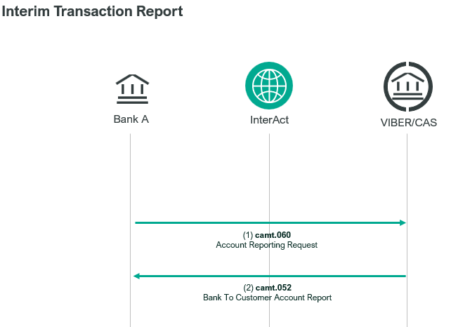
The message includes the executed payment transactions (in Document/BkToCstmrAcctRpt/Rpt/Ntry element) grouped by debit and credit transaction orders, in ascending order according to their values.

Former – Summary of Outstanding Operations Response – Response to a general enquiry

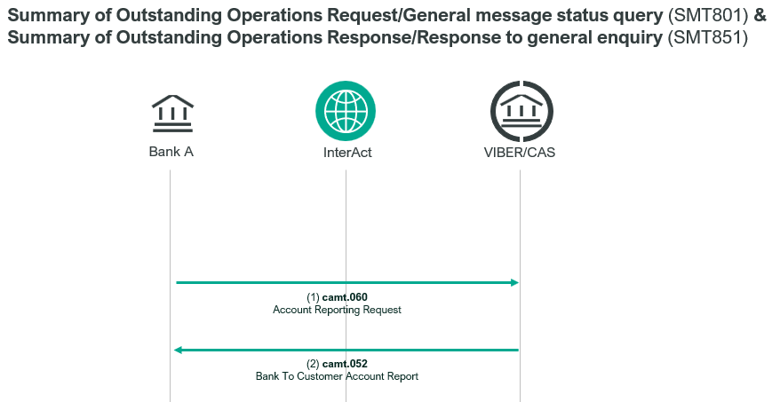
CAS uses a camt.052.001.08 SWIFT message in response to a general enquiry (camt.060.001.05) from a direct participant.

Element specification
The below table includes the SWIFT format specification.
M/O | Element | MX options | 941 | 942 | 851 | MT equivalent field | MT equivalent field name
M | AppHdr/Fr/FIId/FinInstnId/BICFI | CAS settlement BIC | X | X | X | n/a
M | AppHdr/To/FIId/FinInstnId/BICFI | receiving BIC | X | X | X | n/a
M | AppHdr/BizMsgIdr | Business Message Identifier | X | X | X | n/a
M | AppHdr/MsgDefIdr | camt.052.001.08 | X | X | X | n/a
M | AppHdr/BizSvc | swift.iap.02 | X | X | X | n/a
M | AppHdr/CreDt | Creation Date and Time | X | X | X | n/a
M | Document/BkToCstmrAcctRpt/GrpHdr/MsgId | Message Identification | X | X | X | 20 | TRN
M | Document/BkToCstmrAcctRpt/GrpHdr/CreDtTm | Creation Date and Time | X | X | X | 13D  L12 | 941,942: date/time indication  851: CAS action time
M | Document/BkToCstmrAcctRpt/GrpHdr/OrgnlBizQry/MsgId | Original Message Identification | X | X | X | 21 | Related Reference
M | Document/BkToCstmrAcctRpt/Rpt/Id | Report Identification | X | X | X | 28  28C  20 | 941: statement number  942: entry number  851: TRN
M | Document/BkToCstmrAcctRpt/Rpt/RptPgntn/PgNb | Page Number | X | X | X | 28  28C  L03 | 941: sequence number  942: sequence number  851: page number
M | Document/BkToCstmrAcctRpt/Rpt/RptPgntn/LastPgInd | Last Page Indicator | X | X | X | n/a
M | Document/BkToCstmrAcctRpt/Rpt/Acct/Id/Othr/Id | Account Identification (BIC) | X | X | X | 25  L04 (first) | 941,942: primary BIC  851: primary BIC
O | Document/BkToCstmrAcctRpt/Rpt/Bal/Tp/CdOrPrtry/Cd | Balance Type  “OPBD” or “CLBD”(941) “ITBD”(851) | X |  | X | n/a
O | Document/BkToCstmrAcctRpt/Rpt/Bal/Amt | Balance Amount  (Opening/Closing/Interim) | X |  | X | 60F  62F  L09 | Opening Balance and Ccy  Closing Balance and Ccy  Balance and Ccy
O | Document/BkToCstmrAcctRpt/Rpt/Bal/CdtDbtInd | Balance Credit/debit Indicator  “CRDT” or “DBIT” | X |  | X | 60F  62F  L09 | Credit/Debit Indicator
O | Document/BkToCstmrAcctRpt/Rpt/Bal/Dt/DtTm | Balance Date/Time | X |  | X | 60F  62F
O | Document/BkToCstmrAcctRpt/Rpt/TxsSummry/  TtlCdtNtries/NbOfNtries | Total Credit Entries/Number | X | X |  | 90C | number of credits
O | Document/BkToCstmrAcctRpt/Rpt/TxsSummry/  TtlCdtNtries/Sum | Total Credit Entries/Sum | X | X |  | 90C | sum of credits
O | Document/BkToCstmrAcctRpt/Rpt/TxsSummry/  TtlDbtNtries/NbOfNtries | Total Debit Entries/Number | X | X |  | 90D | number of debits
O | Document/BkToCstmrAcctRpt/Rpt/TxsSummry/  TtlDbtNtries/Sum | Total Debit Entries/Sum | X | X |  | 90D | sum of debits
O | Document/BkToCstmrAcctRpt/Rpt/Ntry/Amt | Entry Amount |  | X |  | 61 | statement line amount and ccy
O | Document/BkToCstmrAcctRpt/Rpt/Ntry/CdtDbtInd | Entry Credit/Debit Indicator  “CRDT” or “DBIT” |  | X |  | 61 | statement line credit/debit indicator
O | Document/BkToCstmrAcctRpt/Rpt/Ntry/Sts/Cd | Entry Status Code: “BOOK” |  | X |  | n/a
O | Document/BkToCstmrAcctRpt/Rpt/Ntry/BookgDt/DtTm | Entry Booking Date and Time |  | X |  | 61 | statement line posting date/time
O | Document/BkToCstmrAcctRpt/Rpt/Ntry/ValDt/Dt | Entry Value Date |  | X |  | 61 | statement line value date
O | Document/BkToCstmrAcctRpt/Rpt/Ntry/BkTxCd/Prtry/Cd | Entry Bank Transaction Code |  | X |  | 61 | statement line transaction type
O | Document/BkToCstmrAcctRpt/Rpt/Ntry/NtryDtls/TxDtls/  Refs/InstrId | Entry Instruction Identification |  | X |  | 61 | statement line TRN
O | Document/BkToCstmrAcctRpt/Rpt/Ntry/NtryDtls/TxDtls/  RltdPties/Dbtr/Pty/Id/OrgId/AnyBIC | Entry Debtor BIC |  | X |  | 61 | statement line debit BIC
O | Document/BkToCstmrAcctRpt/Rpt/Ntry/NtryDtls/TxDtls/  RltdPties/Cdtr/Pty/Id/OrgId/AnyBIC | Entry Creditor BIC |  | X |  | 61 | statement line credit BIC
O | Document/BkToCstmrAcctRpt/Rpt/AddtlRptInf | Additional Report Information | X | X | X | 86  34F  see below | 941,942: “REQUESTED BY MEMBER”  942: floor limit amount and ccy  851: see below (type 1,2 or 3)

Format specification
- Document/BkToCstmrAcctRpt/GrpHdr/CreDtTm indicates the time when CAS started to generate the camt.052.001.08 SWIFT message.
- Document/BkToCstmrAcctRpt/GrpHdr/OrgnlBizQry/MsgId contains the Message Identification of the sent camt.060.001.05 to which it responds.
- Document/BkToCstmrAcctRpt/Rpt/Acct/Id/Othr/Id contains the BIC code of the sender of the message, whose direct participant status is being queried with the enquiry.
- Document/BkToCstmrAcctRpt/Rpt/Bal element’s tags are mandatory for Balance Report and Outstanding Operations Response:
/Tp/CdOrPrtry/Cd shows if it is the
- opening balance (OPBD) or
- closing balance (CLBD) for Balance Report and
- interim balance (ITBD) for Outstanding Operations Response.
/Amt indicates the balance of the direct participant at the time of sending the camt.052.001.08 SWIFT message.
/CdtDbtInd contains the Credit/debit Indicator of the Amount:
  - CRDT means positive balance,
  - DBIT means negative balance.
/Dt/DtTm provides the time of sending the camt.052.001.08 SWIFT message.
- Document/BkToCstmrAcctRpt/Rpt/TxsSummry element’s tags are mandatory for Balance Report and Interim Balance report:
/TtlCdtNtries/NbOfNtries provides the number of credit messages and
/TtlCdtNtries/Sum shows the total amount credited up to the time of sending the camt.052.001.08 message.
/TtlDbtNtries/NbOfNtries provides the number of debit messages and
/TtlDbtNtries/Sum shows the total amount debited up to the time of sending the camt.052.001.08 message.
- Document/BkToCstmrAcctRpt/Rpt/Ntry element’s tags are mandatory for Interim Balance Report which describes the settled transactions:
/Amt contains the amount and currency of the order,
/CdtDbtInd shows if it is a debit (DBIT) or credit (CRED) transaction order,
/Sts/Cd is always: “BOOK”,
/BookgDt/DtTm contains the date of submitting the order,
/ValDt/Dt contains the date of execution,
/BkTxCd/Prtry/Cd contains the type of the order (in “Snnn” format, where the last three characters are the SWIFT message type of the message, e.g. NTRF for account transfer: for example S009 means that the order is a pacs.009.001.08 message),
/NtryDtls/TxDtls/Refs/InstrId contains the Message Identification of the order
/NtryDtls/TxDtls/RltdPties/Dbtr/Pty/Id/OrgId/AnyBIC contains the 11-character BIC code of the debit party and
/NtryDtls/TxDtls/RltdPties/Cdtr/Pty/Id/OrgId/AnyBIC contains the 11-character BIC code of the credit party.
Repeating tags: One instance of Ntry for each statement line being reported.
Pagination: Wraps to multiple messages (each with unique MsgId) after every 50 statement lines being reported.
- Document/BkToCstmrAcctRpt/Rpt/AddtlRptInf Additional Report Information
- In case of a Balance Report, it indicates the reason for generating the camt.052.001.08 SWIFT message and it is always populated with „REQUESTED BY MEMBER”.
- In case of an Interim Transaction Report, it is populated with „REQUESTED BY MEMBER”. This element also contains the floor limit amount (with decimal point in it) and currency if it was indicated in the incoming camt.060.001.08 message. These data are concatenated, separated by „//”. E.g.: „REQUESTED BY MEMBER//HUF1.00”
- In case of an Outstanding Operations Response, it is dependent on type (1, 2 or 3).
Component fields are concatenated with the former MT field tag, separated by //, with the type number at the start as follows:
Field L04 contains the BIC code of the sender of the message, whose direct participant status is being queried with the enquiry.
Field L01 shows the status of the CAS / queue / payment / or account:
- CAS Object State (CAS) indicates CAS status at the time of querying. CAS status can be the following:
  - CAS/SUSPENDED when the operation of CAS has been suspended, and the settlement process has been stopped.
  - CAS/NOTSUSP, when CAS is not suspended.
- CAS Object State (Queue) contains information pertaining to the queue of the party sending the enquiry. When there is a queue the details of the payment (field L02) is related to the first transaction order in the queue.
The following code_words can be used in this field:
  - QUEUE/BLOCKED-NOFUNDS when a queue was generated for the direct participant and the first transaction order in the queue cannot be settled due to lack of sufficient funds.
  - QUEUE/BLOCKED-CAS when the first transaction order in the queue cannot be settled because the operation of CAS has been suspended.
  - QUEUE/BLOCKED-ACCTSUSP when the first transaction order in the queue cannot be settled because the account of the debit party has been suspended (fully or for debits only).
  - QUEUE/CLEAR when the queue was cleared and there are no transaction orders in queue.
- CAS Object State (Payment): A summary of unsettled transaction orders in CAS. Field L11 that follows this line shows the number of payments in the given state, and field 32B provides the sum of the values of these transaction orders.
  - PAYMENT/AWAITFUNDS when the payment is queued (this includes those which cannot be settled because the debit account is suspended),
  - PAYMENT/CREDITSUSP when the payment cannot be settled because the account of the credit party has been suspended,
  - PAYMENT/PENDING when payment is awaiting start of settlement,
  - PAYMENT/WAREHOUSED = payment is waiting for the new CAS value date to be set.
- CAS Object State (Account) provides information (BIC code) of an account of the direct participant, which has been suspended. Account status can be the following:
  - SUSPENDED when the account has been suspended in CAS for both credit and debit transactions.
  - CREDITSUSP when the account has been suspended for credits only in CAS.
  - DEBITSUSP when the account has been suspended for debits only in CAS.
Type 1 contains the following components:
- CAS settlement status (CAS) – format is as per former MT field L01 (first)
- CAS limit amount and currency – as per L13 (optional)
If one or more reservations has been assigned to the account, it also contains the following:
- CAS reservations amount and currency – as per L14 (optional)
Finally, it contains details concerning the submitter’s payment queue. If a queue is blocked, details of the payment at the head of the queue appear. A queue is always reported as clear when it contains no payments.
- CAS object state (queue) – as per L01 (second, optional)
- CAS message details – as per L02 (optional)
- amount and currency – as per 32B (first, optional)
- e.g. “1//L01 CAS/NOTSUSP//L13 OVERDRAFT/HUF1000000.00//L01 QUEUE/BLOCKED-NOFUNDS//L02 D231028100100OTPVHUHBXXX2310280000981//32B HUF123.00”
Example: OTP Bank requests current status information from CAS (camt.060.001.05, Message Identifier: OR9910121016), which is answered by CAS with the following camt.052.001.08 message.
https://www.mnb.hu/letoltes/camt-052-001-08-type1.txt
Type 2: This type is used to summarise the state of payments within CAS which have not yet been settled. Following the payment state is a count of the number of payments in this state and their total value.
If there are unsettled payments in more than five different states, then a separate type 2 camt.052.001.08 is sent for each batch of five states. If there are no unsettled payments, then no type 2 camt.052s will be generated.
For each payment status, Additional report information type 2 contains the following components:
- CAS bőjét state (payment) – as per former MT field L01 (third)
- CAS object count – as per L11
- amount and currency – as per 32B (second), except decimal point used instead of decimal comma
- e.g. “2//L01 PAYMENT/AWAITFUNDS//L11 12//32B HUF10837635.00//L01 PAYMENT/CREDITSUSP//L11 1//32B HUF900000.00”
Example: https://www.mnb.hu/letoltes/camt-052-001-08-type2.txt
Type 3: This type contains details of Members' accounts which are suspended. It contains each BIC which has a suspended account, consequently a single suspended account linked to multiple BICs will cause multiple entries to be included.
Note that if a participant organisation is suspended, all that organisation’s accounts are suspended, and are listed separately in this message.
If there are more than five suspended accounts, then a separate type 3 camt.052.001.08 is sent for each batch of five accounts. If there are no suspended accounts, then no type 3 camt.052s will be generated.
For each account, Additional report information type 3 contains the following components:
- CAS object state (account) – format is as per former MT field L01 (fourth)
- CAS member BIC – as per L04 (second)
- e.g. “3//L01 ACCOUNT/SUSPENDED//L04 OTPVHUHBXXX”
Example: https://www.mnb.hu/letoltes/camt-052-001-08-type3.txt

Pagination:
Multiple camt.052.001.08s (each with unique MsgId) is generated in response to each camt.060.001.05, with different details in the AddtlRptInf tag.
One message is always generated with AddtlRptInf type 1.
Optionally, one or more messages are generated with AddtlRptInf type 2 (maximum five payment states per message).
Optionally, one or more messages are generated with AddtlRptInf type 3 (maximum five accounts per message).
The page number and last page indicator elements can be used to identify all messages that are part of the same response.

Examples:
- OTP Bank sends a camt.060.001.05 SWIFT message, requesting a Balance Report in a camt.052.001.08 SWIFT message from CAS.
https://www.mnb.hu/letoltes/camt-052-001-08-1-viber.txt
- Element Document/BkToCstmrAcctRpt/Rpt/TxsSummry/TtlDbtNtries/NbOfNtries in the above example shows that 15 debit messages were settled, and
Document/BkToCstmrAcctRpt/Rpt/TxsSummry/TtlDbtNtries/Sum shows that the total debited amount was HUF 20,650,000,000 on the given settlement day up to the time of sending the camt.052.001.08 message.
- Element Document/BkToCstmrAcctRpt/Rpt/TxsSummry/TtlCdtNtries/NbOfNtries in the above example shows that 12 credit messages were settled, and
Document/BkToCstmrAcctRpt/Rpt/TxsSummry/TtlCdtNtries/Sum shows that the total credit amount was 16,950,000,000 HUF on the given settlement day up to the time of sending the camt.052.001.08 message.
- Element Document/BkToCstmrAcctRpt/Rpt/Bal/Amt indicates the balance of the direct participant at the time of sending the camt.052.001.08 SWIFT message, which is 4,268,500,000 HUF in this case, and
Document/BkToCstmrAcctRpt/Rpt/Bal/CdtDbtInd “CRED”shows that it is a positive balance.
- Element Document/BkToCstmrAcctRpt/Rpt/AddtlRptInf – indicates the reasons for generating the camt.052.001.08 SWIFT message. It contains the following codewords: REQUESTED BY MEMBER

- At 10:00 ING Bank sent their first camt.060.001.05 message, requesting an interim transaction report. Again, at 12:00 they also asked for an interim transaction report for transaction orders settled between 10:00 and 12:00. In its camt.052.001.08 response message CAS notified them that in the period that has passed 1 credit and 2 debit transaction orders were settled on their account.
For example, debit: HUF 25,000,000
message type: pacs.09.001.08
Sender of the message: INGBHUHBXXX
Receiver of the message: OTPVHUHBXXX
Time of settlement: 09:23
Message Identifier: BK199910121003
CAS sent the following camt.052.001.08 message:
https://www.mnb.hu/letoltes/camt-052-001-08-2-viber.txt

