camt.053.001.08 Bank To Customer Statement (MT equivalent: MT950 – Statement Message – Closing statement for the day)

Scope
At the time of closing CAS sends a Statement in a camt.053.001.08 message to all direct participants. The Statement Message contains grouped debit and credit transactions settled on the given settlement day, in ascending order sorted according to their value.
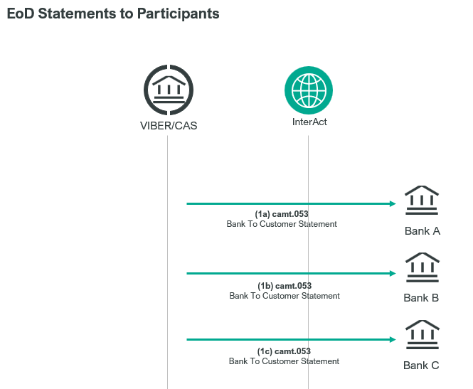

Element specification
The below table includes the SWIFT format specification.
M/O | Element | MX options | MT field | MT field name
M | AppHdr/Fr/FIId/FinInstId/BICFI | Sender BIC (MANEHU2AXXX9 | n/a
M | AppHdr/To/FIId/FinInstId/BICFI | receiving BIC | n/a
M | AppHdr/BizMsgIdr | Business Message Identifier | n/a
M | AppHdr/MsgDefIdr | camt.053.001.08 | n/a
M | AppHdr/BizSvc | swift.iap.02 | n/a
M | AppHdr/CreDt | Creation Date and Time | n/a
M | Document/BkToCstmrStmt/GrpHdr/MsgId | Message Identification | 20 | Transaction Reference Number
M | Document/BkToCstmrStmt/GrpHdr/CreDtTm | Creation Date and Time | n/a
M | Document/BkToCstmrStmt/Stmt/Id | Statement Identification | 28C | Statement Number
M | Document/BkToCstmrStmt/Stmt/StmtPgntn/PgNb | Page Number | 28C | Sequence Number
M | Document/BkToCstmrStmt/Stmt/StmtPgntn/LastPgInd | Last Page Indicator | n/a
M | Document/BkToCstmrStmt/Stmt/Acct/Id/Othr/Id | Account Identification | 25 | Account Identification
M | Document/BkToCstmrStmt/Stmt/Bal/Tp/CdOrPrtry/Cd | Balance Type “OPBD” = opening balance | n/a
M | Document/BkToCstmrStmt/Stmt/Bal/Amt | Amount and Currency | 60F | Opening Balance Amount/Ccy
M | Document/BkToCstmrStmt/Stmt/Bal/CdtDbtInd | Credit Debit Indicator (“CRDT” or “DBIT”) | 60F | Opening Balance C/D Indicator
M | Document/BkToCstmrStmt/Stmt/Bal/Dt/Dt | Date | 60F | Opening Balance Date
M | Document/BkToCstmrStmt/Stmt/Bal/Tp/CdOrPrtry/Cd | Balance Tye “CLBD” = closing balance | n/a
M | Document/BkToCstmrStmt/Stmt/Bal/Amt | Amount and Currency | 62F | Closing Balance Amount/Ccy
M | Document/BkToCstmrStmt/Stmt/Bal/CdtDbtInd | Credit Debit Indicator (“CRDT” or “DBIT”) | 62F | Closing Balanca C/D Indicator
M | Document/BkToCstmrStmt/Stmt/Bal/Dt/Dt | Date | 62F | Closing Balance Date
M | Document/BkToCstmrStmt/Stmt/Ntry/Amt | Entry Amount | 61 | Statement Line: Amount
M | Document/BkToCstmrStmt/Stmt/Ntry/CdtDbtInd | Credit Debit Indicator (“CRDT” or “DBIT”) | 61 | Statement Line: C/D Indicator
M | Document/BkToCstmrStmt/Stmt/Ntry/Sts/Cd | “BOOK” | n/a
M | Document/BkToCstmrStmt/Stmt/Ntry/BookgDt/DtTm | Booking Date and Time | 61 | Statement Line: Entry Date
M | Document/BkToCstmrStmt/Stmt/Ntry/ValDt/Dt | Value Date | 61 | Statement Line: Value Date
M | Document/BkToCstmrStmt/Stmt/Ntry/BkTxCd/Prtry/Cd | Bank Transaction Code | 61 | Statement Line: Transaction Type
M | Document/BkToCstmrStmt/Stmt/Ntry/NtryDtls/TxDtls/Refs/InstrId | Instruction Identification | 61 | Statement Line: TRN
O | Document/BkToCstmrStmt/Stmt/Ntry/NtryDtls/TxDtls/Refs/UETR | UETR | n/a
M | Document/BkToCstmrStmt/Stmt/Ntry/NtryDtls/TxDtls/RltdPties/Dbtr/Pty/Id/OrgId/AnyBIC | Debtor BIC | 61 | Statement Line: Debit BIC
M | Document/BkToCstmrStmt/Stmt/Ntry/NtryDtls/TxDtls/RltdPties/Cdtr/Pty/Id/OrgId/AnyBIC | Creditor BIC | 61 | Statement Line: Credit BIC

Format specification
- Document/BkToCstmrStmt/Stmt/Ntry element contains the former MT field 61 which describes the executed payment transactions:
/Amt: amount and currency
/CdtDbtInd: “CRDT” for credit or “DBIT” for debit transactions
/Sts/Cd: type of the payment order message is Snnn, where the last three characters are the SWIFT message type of the message, e.g.: for example S009 means that the order is an MX pacs.009.001.08 message, “NTRF” for account transfer.
/NtryDtls/TxDtls/Refs/InstrId: Message Identifier of the payment order
/NtryDtls/TxDtls/RltdPties/Dbtr/Pty/Id/OrgId/AnyBIC: 11-character BIC code of the debit party
/NtryDtls/TxDtls/RltdPties/Cdtr/Pty/Id/OrgId/AnyBIC: 11-character BIC code of the credit party
- Pagination: The Document/BkToCstmrStmt/Stmt tag contains one instance of Ntry for each statement line. If more than 50 statement lines are being reported, then a separate camt.053.001.08 (each with unique MsgId) is sent for each batch of 50 statement line. The page number and last page indicator elements can be used to identify all messages that are part of the same statement. Transactions are grouped by debit then credit and sorted into ascending value order.

Example
- On 12-08-2023 OTP Bank receives the following message at the time of closing CAS.
https://www.mnb.hu/letoltes/camt-053-001-08-1-viber.txt

