Camt.060.001.05 – Account Reporting Request (MT equivalent: MT298/SMT 801 – Summary of Outstanding Operations Request – Query about general message status and MT920 – Transaction Information Request Message – Request for information about settled transaction orders)

Scope
A direct participant can send a camt.060.001.05 message to
- query the status of CAS, the status of a queue, or the status of individual payment orders, accounts, balances, and daily credit lines,
- request Balance Report or
- request an Interim Transaction Report.
CAS responds with a camt.052.001.08 message to the enquiry.
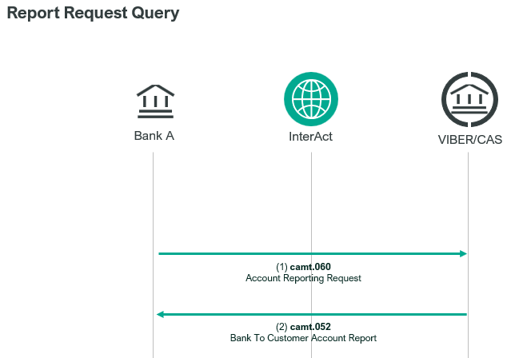

Element specification
The below table includes the SWIFT format specification.
M/O | Element | MX options | MT equivalent field | MT equivalent field name
M | AppHdr/Fr/FIId/FinInstnId/BICFI | CAS settlement BIC | n/a
M | AppHdr/To/FIId/FinInstnId/BICFI | Receiving BIC (MANEHU2AXXX) | n/a
M | AppHdr/BizMsgIdr | Business Message Identifier | n/a
M | AppHdr/MsgDefIdr | camt.060.001.05 | n/a
M | AppHdr/BizSvc | swift.iap.01 | n/a
M | AppHdr/CreDt | Creation Date and Time | n/a
M | Document/AcctRptgReq/GrpHdr/MsgId | Message Identification | 20 | Transaction Reference Number
M | Document/AcctRptgReq/GrpHdr/CreDtTm | Creation Date and Time | n/a
M | Document/AcctRptgReq/RptgReq/ReqdNssgNmId | Request Message Name Identification | 12 | Sub-Message Type
M | Document/AcctRptgReq/RptgReq/AcctOwnr /Pty/Id/OrgId/AnyBIC | Account Owner BIC | 25 (920)  L04 (801) | Account Identification  CAS Settlement BIC
O | Document/AcctRptgReq/RptgReq/ReqdTxTp/Sts/Cd | Status Code: “BOOK” | n/a
O | Document/AcctRptgReq/RptgReq/ReqdTxTp/CdtDbtInd | Credit Debit Indicator | n/a
O | Document/AcctRptgReq/RptgReq/ ReqdTxTp/FlrLmt/Amt | Floor Limit Amount and Currency | 34 F | Debit/Credit Floor Limit Indicator
O | Document/AcctRptgReq/RptgReq/ ReqdTxTp/FlrLmt/CdtDbtInd | Floor Limit Credit Debit Indicator | 34F | Debit/Credit Floor Limit Indicator

Format specification
- Document/AcctRptgReq/RptgReq/ReqdNssgNmId element indicates the report type requested by the direct participant. It may contain the following information:
  - Balance Report (941)
  - Interim Transaction Report (942)
  - Outstanding Operations Response (851)
- Document/AcctRptgReq/RptgReq/AcctOwnr /Pty/Id/OrgId/AnyBIC element contains the BIC code of the sender of the message, whose direct participant status is being queried with the enquiry.
- Document/AcctRptgReq/RptgReq/ ReqdTxTp/FlrLmt/Amt element specifies a lower limit, which means that mostly when an Interim Transaction Report (942) message is requested, the sender defines a limit value so that only information about transaction orders exceeding that limit should be reported to them. CAS supports the specification of one floor limit applicable to both debits and credits. If multiple floor limits are specified, the lowest will be used for both debits and credits. Therefore

Example
- OTP requests current status information from CAS.
mnb.hu/letoltes/camt-060-001-05-1-viber.txt
- OTP Bank sends a camt.060.001.05, requesting a Balance Report in a camt.052.001.08 SWIFT message from CAS.
mnb.hu/letoltes/camt-060-001-05-2-viber.txt

