25 February 2003
NOTES
to the methodological changes to balance of payments statistics implemented in February 2003 and the new data release and revision methods to be introduced in 2003

I. A brief summary of the methodological changes

- As from 2003, the Magyar Nemzeti Bank will, in the area of trade in goods, change its statistical methodology of compiling Hungarian balance of payments statistics from recording settlement data to a more accurate system of recording transactions according to the accrual principle. Customs data will be first used at the time of publishing the balance of payments data for 2002. Consistent with this change, the Bank will make data comparable back to 1995. The time series accessible on the MNB's website will change accordingly. For the purposes of a more detailed analysis of the effects of the changes, the Bank will continue to make available earlier time series for 1995–2002 for a limited period of time. The time constraint will not affect statistical data for 1995 compiled on the basis of the pre-2003 methodology – they will be part of the official data series; thus earlier and revised data can be compared any time. With the introduction of the method of recording trade in goods in accordance with the international methodology, the existing inconsistencies with international statistical standards will be eliminated.
In the member states of the EU, intra-Community trade in goods is recorded within the framework of the INTRASTAT system, while extra-Community trade is recorded on the basis of the data provided by foreign trade statistics based on customs documents.
Currently, trade in goods as stated in Hungary's balance of payments fundamentally records foreign trade payments on the basis of reports from credit institutions and enterprises.
- In addition, in order to create consistency between the balance of payments and the national accounts, the Bank will, in agreement with the CSO, implement methodological changes in the compilation of travel data.
With the inclusion of customs data in the balance of payments, (i) the terms of the delivery of transactions will change (trade in goods will be recorded on the basis of customs data converted to f.o.b./f.o.b. terms instead of the contractual values of trade in goods in the balance of payments); and (ii) certain items of the current account and the financial account as well as the item for net errors and omissions will also change.
With the compilation of travel data according to the new method, the part of real estate investment, which has so far been recorded within the current account, will be re-classified as direct investment in the financial account.
The changes discussed above do not affect actual real economic and income developments or the external equilibrium of the national economy – they only pertain to the method of statistical recording, thereby improving the quality and analytical power of the macroeconomic statistics affected and enhancing their international comparability.
Simultaneously with the implementation of the methodological changes discussed above, the Bank will re-record corporate borrowing and lending data reported late for the corresponding periods, continuing the practice it is has used systematically since 1999, and it will correct the data report sheets accordingly, both at the time of the release of 2002 data.
The Bank used the data revision related to the methodological changes to present the balance of payments and international investment position (IIP) data in a satisfactory structure from 1995, in accordance with the international standard for the compilation of balance of payments statistics published in 1993.
* * * * *
1 Recording trade in goods in the balance of payments

1.1 The situation prior to the methodological change

Three sources provided information in respect of Hungary's total foreign trade in the period prior to 2003: (i) customs statistics recording the physical crossing of customs frontiers of goods, (ii) the national accounts, which relied on customs statistics with certain adjustments and (iii) the balance of payments statistics containing cash flows, based on reports by credit institutions and enterprises. In most cases, data reported in the customs statistics and the balance of payments were significantly different, on both monthly and quarterly bases. This phenomenon had to be explained continuously to users, particularly in the case of occasional large monthly differences.
Gaps stem in part from the differences between statistical methodologies:
- trade in goods as recorded in the balance of payments on the basis of reports by credit institutions and enterprises does not include goods for processing and contributions in kind, in contrast with customs statistics,
- the two statistical systems value trade in goods on the basis of different terms of delivery,
- the time of recording transactions in the statistics varies, due to the different sources of data (physical movements of goods vs. information from credit institutions).
With the help of available data, a large part of the differences attributable to the causes discussed in points 1 and 2 above can be eliminated from monthly (gross) customs statistics. However, the net customs data series derived in this way continued to differ significantly from the goods data series of the balance of payments, in respect of both turnover level and the balance.
Taking into account that the current account and the customs statistics were in the past compiled on the basis of different data sources (the factor noted in point 3), the difference between the two statistics would still be unavoidable even if the same transactions were recorded by the two systems.
1.2 Incorporating data on trade in goods into the balance of payments
Similarly to the national accounts, the international methodology also recommends the accrual basis of accounting, in which the time of recording transactions is linked to changes in ownership. There is a wide use of customs statistics in international practice. Over the past few years, the MNB has been making preparations to incorporate customs statistics into the balance of payments. The conclusion of the agreement on cooperation in statistical activities of mutual concern between the CSO, being responsible for producing customs statistics, and the MNB in 2002 played an important role in timing the implementation of this change.
- One of the important problems raised by data quality is that, in the current system of publishing customs data, monthly data for the reference year change retrospectively and continuously until publication of the yearly data. However, the expected difference between the final and the preliminary data is not zero, as the data are complemented in the majority of cases. In analysing developments in trade in goods, the MNB's statistical press releases have included estimates of the size of these data supplements over the past years. From 2003, the MNB will incorporate data on trade in goods into the balance of payments statistics on the basis of data supplements estimated on the basis of the agreed methodology.
- Another factor of data quality is the proper recording of goods for processing. Currently, customs statistics show a permanent import surplus of goods for processing which amounts to 1% of GDP annually. Provided that the Bank is unable to identify precisely the sources and that whether this actually is an additional resource for the national economy or only a consequence of accounting problems, the import surplus of goods for processing is recorded as a statistical error in the balance of payments. In order to clarify the issue, the Bank has requested for and received information from the CSO which is not included in the foreign trade database. This helped the Bank to narrow the gap already noted and, consequently, to reduce the size of statistical error in the period affected by the data revision.

1.3 Revisions applied in the course of integrating customs statistics into the balance of payments

The incorporation of customs statistics into the balance of payments involves replacing former data for transactions in goods with those derived from the customs statistics. To ensure that the balance of payments as a whole conforms to international methodological standards, a number of further revisions need to be implemented:
- Consistent with international methodological standards, exports and imports of goods are valued f.o.b./f.o.b. (i.e. the value at the customs frontier of the exporting economy), just as in the national accounts. However, customs statistics record goods trade at c.i.f./f.o.b. (i.e. the value at the Hungarian frontier). The c.i.f. value of imports should be replaced by the f.o.b. value in the balance of payments. The Bank receives the f.o.b. data for goods imports from the CSO. This change in the terms of delivery does not have any effect on the aggregate balance of goods and related shipping services, as residents’ receipts from and expenditure on a particular transaction are the same regardless of the terms of delivery used for the statistical measurement of transactions. The methodologically correct revision to shipping services is also implemented using the data reported by the CSO.
- It should be taken into account that certain transactions in goods in the balance of payments (such as goods not crossing the frontier and goods procured in ports by carriers) are not recorded in the customs statistics and will continue to be provided by the transaction codes of credit institutions.
- Under international methodology, goods for processing on a gross basis and repairs on a net basis are recorded as transactions in goods. (Until now, they were recorded under services in the Hungarian balance of payments, both of them in net terms.) Once customs statistics are incorporated, the source of data for processing and repairs will also become the customs statistics, so the relevant titles should be removed from services. Accordingly, there will be a change in the items of trade-related services and construction services in the balance of payments data published until now.
- As the difference between the balance of transactions in goods as recorded in the balance of payments and customs statistics will also have an effect on the current account balance, there will also be a change in net financing in the financial account, in accordance with the double entry system also applied in balance of payments statistics. One of the elements of the change is that contributions in kind associated with direct investment will be recorded under goods, which will also have an effect on the entry for net direct investment.
- The difference between transactions in goods as recorded in customs statistics, (excluding contributions in kind and corrected using additional information received from the CSO on goods for processing and by adding net repairs) and net settlements data, (corrected in the way presented above), is offset, in accordance with the double entry system, by means of corresponding entries under other short-term claims/liabilities of the financial account. This way of recording implies that the difference between payment transactions and the physical exports and imports of goods have been financed by economic agents in the form of trade credit. The difference is recorded appropriately as a claim or liability, using the appropriate sign.
- Any difference in addition to the above-noted discrepancy results from unidentifiable transactions and is recorded under net errors and omissions. The incorporation of the customs statistics may lead to statistical error due primarily to recording problems associated with goods for processing.
2. Travel
2.1 The situation prior to the change in methodology
Apart from the balance of payments, there is no other statistical framework which records residents and non-residents’ expenditures on goods and services during travel into a foreign country or into Hungary, respectively. Simultaneously with the release of the balance of payments for December 1999, the MNB, for methodological considerations, revised the monthly travel data for the period 1995–1999. And, since then, it compiles data on the basis of a new methodology. However, the CSO continued to record the travel data in the national accounts using the former methodology. As a consequence, the balance of payments and the national accounts showed different travel data – GDP recorded lower levels of travel receipts (from 1995) and expenditures (from 1998) than the balance of payments.
The revision starting from the 1999 balance of payments data was motivated by the need to record travel-related payment flows which had previously received no, or only inadequate, treatment in the balance of payments statistics, due to lack of sufficient information.

The revision had two components:
- the balance of foreign currency transactions on households' foreign currency accounts was recorded under travel and
- the portion exceeding a certain limit of foreign currency exchanged by residents at currency traders was recorded under travel receipts instead of the category for foreign currency purchased for travel purposes (reverse expenditure).
2.2 The new methodology
In order to create consistency in travel data recorded in various macroeconomic statistics, the MNB, in close cooperation with the CSO, invited proposals for a survey of travel in June 2000. Based on the outcome of the survey, conducted involving external experts, revenue and expenditure data for the period 1995–2002 have been revised in a joint effort. The revisions have been implemented to the satisfaction of all parties concerned.
The calculations were based on responses to a questionnaire survey conducted in August 2000 with the participation of 1,788 customers in 23 branches of 7 commercial banks (with the on-site assistance of an interviewer if requested). The questions referred to the origin of the foreign currency the respondent paid into his or her personal foreign exchange account or, in the case of withdrawals, his or her intentions with the foreign currency withdrawn from the account. In the compilation of travel statistics, the Bank relied on these responses, in addition to various natural indicators (such as the number of non-resident arrivals and the number of Hungarians travelling abroad, nights spent at some paying guest accommodation as well as other data (such as rates of inflation, an 1998 survey on non-resident visitors’ expenditures) and model calculations.
In addition to the travel data, the revisions applied under the new method also have an effect on the entries for income (compensation of employees), current transfers (gifts) and direct investment (real estate investment) in the balance of payments.
The current methodology for the balance of payments has been changed to the extent that it is not the balance of households’ foreign currency account transactions that is recorded under travel but only that portion of receipts and expenditures that is associated with travel.
Beginning with the data for January 2001, monthly statistics are compiled, on the basis of the methodology applied for the period between 1995 and 2000 and using the coefficients derived with the method, by allocating residents’ foreign exchange transactions (i.e. the combined values of transactions on household foreign currency accounts and individuals’ over-the-counter sales and purchases of foreign currency at banks) to different items of the balance of payments.
There is also a change in the treatment of the re-exchange of foreign currency purchased for travel purposes (reverse expenditure). Beginning with the data for January 2002, 5% of the travel expenditure for the month preceding the reference month is recorded as reverse expenditure, which is the amount of foreign currency left from trips and re-exchanged into forints. The portion exceeding this percentage of foreign currency exchanged by residents at currency traders is recorded under travel receipts.

Impact of the changes on the current account and net debts
As an effect of the changes introduced, the current account deficit stated was lower in the period from 1995 to 1998 and again in 2002, but higher in the period from 1999 to 2001, compared with what has been published to date.

The inclusion of customs statistics has affected trade in goods, services (transportation, trade-related and construction services), direct investment (equity capital), other investments (trade credits) and the item for net errors and omissions. Travel-related corrections have influenced services (travel), income (compensation of employees), current transfers and direct investment (equity capital).
The IIP has also changed in line with the changes in the current account deficit and the structure of financing. The stock of net external debt of the national economy was nearly EUR 0.7 billion higher at the end of December 2002 than had been calculated on the basis of the earlier method. (For detailed figures and charts, see the Appendix.)
Summary table on revisions caused by methodological changes (change)
II. Changes to the system of data releases and revisions as of 2003
Under the current Hungarian practice of data releases, the MNB publishes the country's preliminary current account on the 3rd of the second month following the reference month and a final balance of payments as well as stock data on the 18th. As of 2003, the system of the publication and the revision of balance of payments data will be changed. Simultaneously with the implementation of the aforementioned methodological changes in the compilation of the balance of payments statistics, the Bank will also have to revise its current policy of data releases and revisions, adopting the principle that data should be regularly revised until new sources of information can improve their accuracy.
- Changes in the method of publication:
- Only the balance of payments consisting of the main aggregates will be published monthly along with statistics on the stock of international reserves. In contrast with the current practice; however, stock data will not be published. The latter, together with a detailed balance of payments, will only be compiled and published quarterly and annually. The deadline for monthly releases will fall in the T+40–46 calendar-day interval designated by T+30 working days. The deadlines for the quarterly and annual releases will be adjusted to the end of the quarter following the reference period (T+3M).
- The new publication method will also entail the Bank’s changing its current revision practice:
- Monthly data will be modified at the time of releasing and revising quarterly and annual data. They will be revised at the time of the release of data for the reference quarter+3 months and also each time when annual data including those for the reference month are revised.
- Quarterly data will only be released once (reference quarter+3 months), with the number of quarterly revisions being connected to the release of annual data and annual revisions. Data for Q1, Q2 and Q3 will be revised three times (reference year+3 months, reference year+15 months and, finally, reference year+27 months); Q4 data will be revised twice, at the time of the revision of annual data (reference year+15 months and reference year+27 months).
As quarterly releases will be separate from monthly releases, there will be an opportunity to reflect a large part of usual monthly variations in customs statistics continuously in the balance of payments.
- Annual data will be released once (reference year+3 months – incorporation of final customs statistics), and will be revised twice (reference year+15 months – processing the questionnaire on direct investment and reference year+27 months – comparisons with the final APEH TÁSA database), in order to record reinvested earnings. (For the respective dates of the publication and regular revision of the balance of payment and IIP, see the Appendix.)
The new publication and data revision policy is consistent with the information requirements of domestic monetary policy, since analyses providing the basis for decisions (such as the Quarterly Report on Inflation) are performed on the basis of quarterly data.
In accordance with the current practice, which is consistent with international data dissemination standards, balance of payments data will continue to be released on pre-announced dates also from 2003 onwards.

Appendix

Summary table on revisions caused by methodological changes

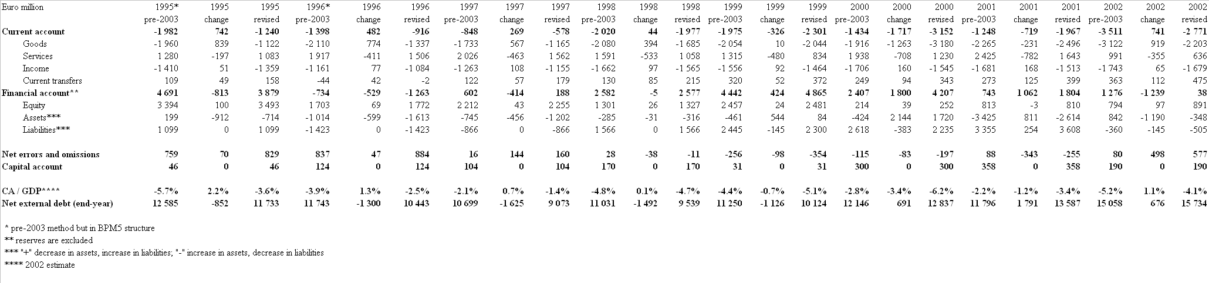

Patterns of timing for dissemination and regular revisions of Balance of payments and International investment position statistics
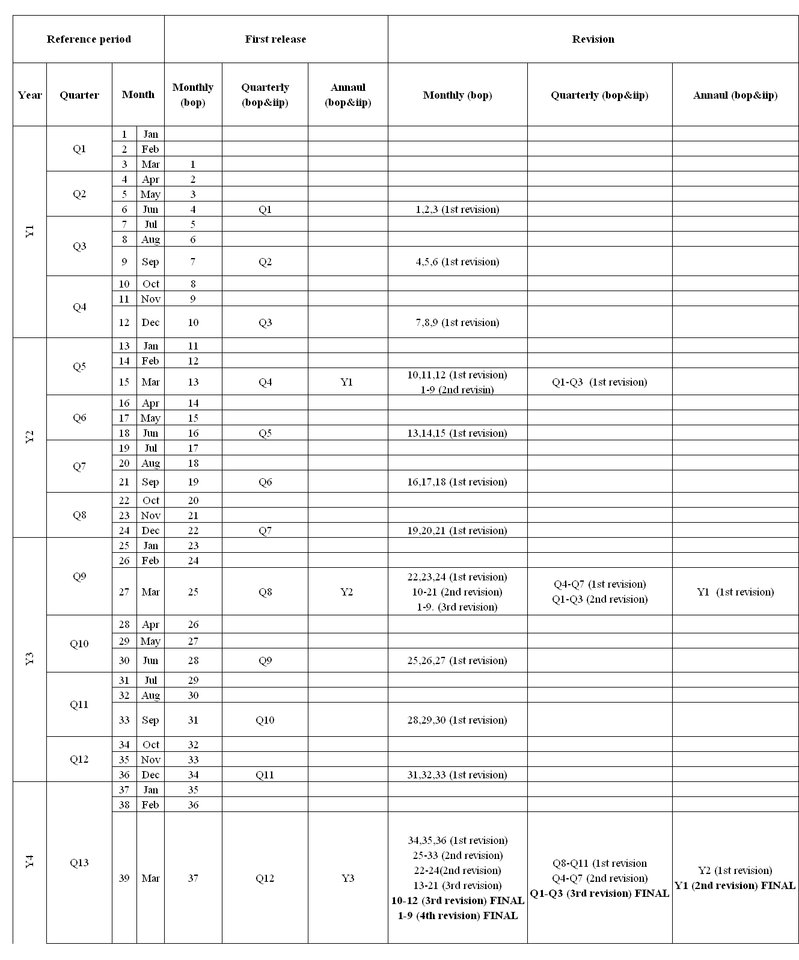

Although the balance of payments for December 2002, compiled on the basis of the earlier methodology, has not been published as part of the official time series, it is also being published as part of the earlier, separately downloadable time series.
Another important factor will be the recording of reinvested earnings on the basis of data derived from the corporate questionnaire introduced jointly with the CSO. The balance of payments also containing reinvested earnings will be first published in 2004, at the time of the release of 2003 data.
In Hungary, simultaneously with the country's accession to the EU, the CSO will adopt the INTRASTAT system.
The Balance of Payments Manual, 5th Edition (BPM5), issued by the International Monetary Fund in 1993.
Although from this perspective customs-based foreign trade statistics are not perfect either, as even with the observation and registration of border-crossing the change in ownership does not fully materialise, i.e. adjustment to the time of recording in business partners' books, it is nevertheless in greater consistency with the principle of accrual-based accounting than the method of recording on the basis of bank reports.
This is hoped to offset the problem that the revision of data for the earlier months of the reference year will only be revised quarterly and yearly, according to the Bank's new publication and revision policy to be introduced form 2003 and, consequently, the balance of payments will only gradually reflect continuous monthly revisions of custom statistical data.
Even though the CSO also publishes statistical information on travel in addition to the MNB, the CSO data primarily cover real factors (such as the number of non-resident tourists, number of guest nights, hotel use, breakdown by type of accommodation, etc.).
A detailed description of the correction can be found on the Bank's website at Financial data/Statistical releases in the document ‘Retroactive changes to BOP data for 1995–99 due to revision of statistical methodology.
As of 1999, the Bank revises monthly transaction and stock data going back 24 months, simultaneously with the publication of end-of-year final balance of payments data. This has been warranted by the need to discontinue the gap between delays in the publication of corporate reports on borrowing and the monthly release of statistics. Accordingly, when pre-determined data revisions are taken into account, it can be stated that, even under the current practice, balance of payments and stock data can be deemed as final only in the 14th month following the reference year.
The reason why the December 2002 data were published on 25 February, i.e. later than usual, is that the CSO published its (final) customs statistics on 24 February 2003. Therefore, the date of the publication of the balance of payments prepared in line with the new methodology had to be set accordingly. The January 2003 data will be published as per the new system of data releases.
Based on the latest published quarterly data and monthly financial account statistics, estimates can be made on the main stock data for the national economy (e.g. debt and direct investment) each month for the purposes of analysis. However, they will not be released as part of the Bank’s official statistical data.

