Technical parameters and description of the ’Budapest Várnegyed Nemzeti Emlékhely’ (Budapest Castle Quarter National Memorial Site) collector coins

To promote the coins' value transferring and educational role as widely as possible the ’Budapest Várnegyed Nemzeti Emlékhely’ non-ferrous metal coin will be available for purchase at face value for one year from 12 May 2025 at the coin shop of the Magyar Pénzverő Ltd. (Budapest, distr. V, 7 Báthory street) and the webshop (https://www.penzvero.hu/).
On the obverse, in an asymmetrical composition of three circles, on the right, a stained glass window of the ’Lamb of God’ is seen, based on the design by Frigyes Schulek, and a detail of the mural (masonry) around it, adapted to a coin, highlighting the sacral, cultural character of the national memorial site. On the left, in the legend bordering the representation of the stained glass window the inscription ’MAGYARORSZÁG’ (Hungary), within the inner ring the denomination ’3000’ and the wording ’FORINT’ is found. On the edge of the obverse, on the right, the mint mark ’BP.’ and the mint year ’2025’ is featured.
The reverse of the commemorative coin shows a distant view of the Budapest Castle District National Monument from the south-east: with the Castle Garden Bazaar in the foreground, the Buda Castle, the Sándor Palace and the Church of the Assumption of the Buda Castle in the background. On the edge of the reverse, in a legend at the top the inscription ’BUDAPEST VÁRNEGYED’ (Budapest Castle District) is seen, at the bottom, slightly to the right in two lines the lettering ’NEMZETI |EMLÉKHELY’ (National Memorial Site) is placed. The collective logo of national memorial sites is located at the bottom in the centre. The designer's mark of sculptor Gábor Veres appears on the left, hidden in the view in the distance.
The ’Budapest Várnegyed Nemzeti Emlékhely’ collector coin
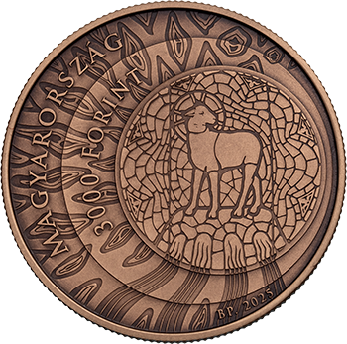 | 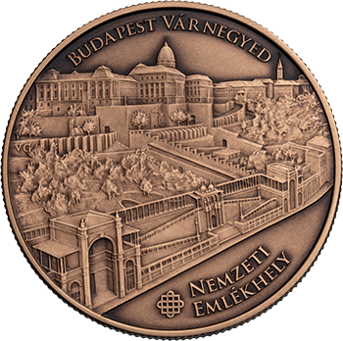
Obverse | Reverse
The circular non-ferrous metal coin from an alloy of copper (90%) and zinc (10%). It weighs 18.4 grams; it is 37 mms in diameter with a reeded edge. 10,000 pieces can be made of the collector coin in a bronze-coated finish.
The collector coin is the 12th addition to the series presenting national memorial sites in Hungary.

