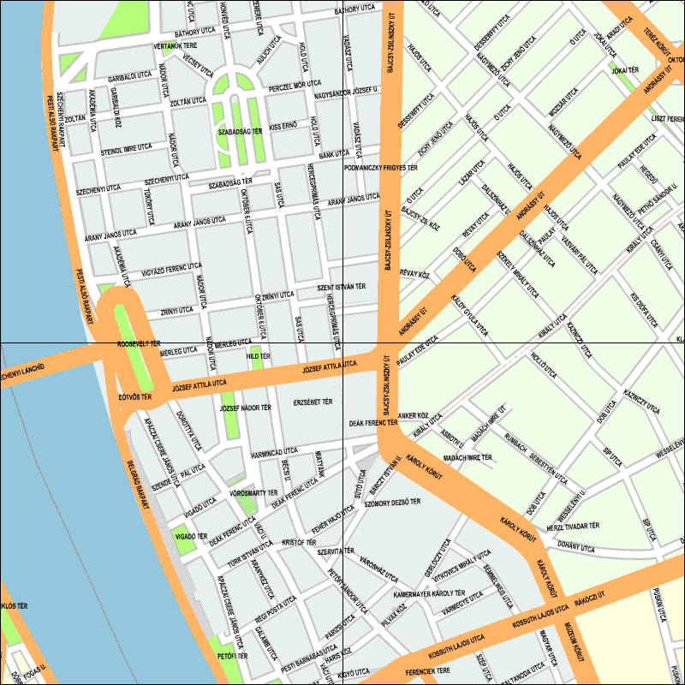
Magyar Nemzeti Bank V building

Magyar Nemzeti Bank Main building

K+K Hotel Opera

Pier No 8

