pacs.009.001.08 financial institution credit transfer (MT equivalent: MT 202 Bank-to-bank payment orders)

Scope
This chapter is related to pacs.009.001.08 type SWIFT messages exchanged between VIBER participants.
This message is used when both the orderer and the beneficiary are direct or indirect VIBER participants.
For a precise definition please refer to under the keyword <bank_to_bank_tr>.
The following table provides an overview of the Y-Copy message flow related to pacs.009.001.08 messages.
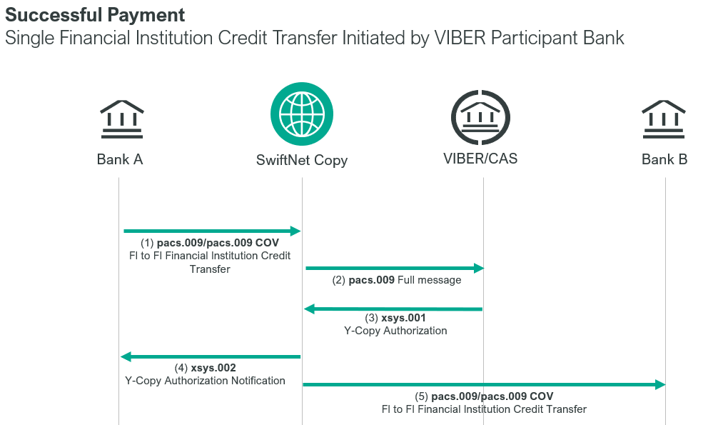
Bank A = debit party
Bank B = credit party
A pacs.009.001.08 message sent by the sender party will be stopped by SWIFT and copying the elements of the message it will forward the full message to the MNB CAS to initiate the settlement. CAS will check and settle the pacs.009.001.08 message, then SWIFT will forward the sent pacs.009.001.08 message to the receiver after receiving the xsys.001 SWIFT response message. This means that the receiver bank will receive the amount indicated in the message irrevocably.

Participants of a pacs.009.001.08 message

Format specification
Below is the SWIFT format specification.
M/O | Element | MX options | MT equivalent field | MT equivalent field Name
M | AppHdr/Fr/FIId/FinInstId/BICFI | CAS settlement BIC | n/a
M | AppHdr/To/FIId/FinInstId/BICFI | Credit party | n/a
M | AppHdr/BizMsgIdr | Business Message Identifier | n/a
M | AppHdr/MsgDefIdr | pacs.008.001.08 | n/a
M | AppHdr/BizSvc | swift.iap.02 | n/a
M | AppHdr/CreDt | Creation Date and Time | n/a
M | Document/FICdtTrf/GrpHdr/MsgId | Message Identification | n/a
M | Document/FICdtTrf/GrpHdr/CreDtTm | Creation Date and Time | n/a
M | Document/FICdtTrf/GrpHdr/NbOfTxs | Number of Transactions  fixed value: ”1” | n/a
M | Document/FICdtTrf/GrpHdr/SttlmInf/SttlmMtd | Settlement Method  fixed value: “CLRG” | n/a
M | Document/FICdtTrf/GrpHdr/SttlmInf/ClrSys/Cd | Clearing System Code  fixed value: “HUF” | n/a
M | Document/FICdtTrf/CdtTrfTxInf/PmtId/InstrId | Instruction Identification | 20 | Transaction Reference Number
M | Document/FICdtTrf/CdtTrfTxInf/PmtId/EndToEndId | End To End Identification | 21 | Related Reference
M | Document/FICdtTrf/CdtTrfTxInf/PmtId/UETR | UETR | n/a
O | Document/FICdtTrf/CdtTrfTxInf/PmtId/ClrSysRef | Numeric Priority | 113 | Business Priority
M | Document/FICdtTrf/CdtTrfTxInf/IntrBkSttlmAmt | Settlement Amount and currency | 32A | Value Date, Currency Code, Amount
M | Document/FICdtTrf/CdtTrfTxInf/IntrBkSttlmDt | Value date | 32A | Value Date, Currency Code, Amount
O | Document/FICdtTrf/CdtTrfTxInf/SttlmPrty | Settlement Priority  (URGT/HIGH/NORM) | 113 | Business Priority
O | Document/FICdtTrf/CdtTrfTxInf/SttlmTmReq/TillTm | Till Time | 13C | Time Indication
O | Document/FICdtTrf/CdtTrfTxInf/SttlmTmReq/FrTm | From Time | 13C | Time Indication
M | Document/FICdtTrf/CdtTrfTxInf/InstgAgt/FinInstnId/BICFI | Instructing Agent |  | Debit party
M | Document/FICdtTrf/CdtTrfTxInf/InstdAgt/FinInstnId/BICFI | Instructed Agent |  | Credit party
O | Document/FICdtTrf/CdtTrfTxInf/Dbtr/FinInstnId/BICFI | Debtor - if populated  otherwise: debit party BIC | 52a | Ordering Institution
O | Document/FICdtTrf/CdtTrfTxInf/DbtrAcct/Id/IBAN | Debtor IBAN | 52d | Ordering Institution
O | Document/FICdtTrf/CdtTrfTxInf/DbtrAcct/Id/Othr/Id | Debtor Account id. | 52d | Ordering Institution
O | Document/FICdtTrf/CdtTrfTxInf/IntrmyAgt1/FinInstnId/BICFI | Intermediary Agent BIC | 56a | Intermediary
O | Document/FICdtTrf/CdtTrfTxInf/IntrmyAgt1Acct/Id/IBAN | Intermediary Agent IBAN | 56d | Intermediary
O | Document/FICdtTrf/CdtTrfTxInf/IntrmyAgt1Acct/Id/Othr/Id | Intermediary Agent Account id. | 56d | Intermediary
O | Document/FICdtTrf/CdtTrfTxInf/CdtrAgt/FinInstnId/BICFI | Creditor Agent BIC | 57a | Account With Institution
O | Document/FICdtTrf/CdtTrfTxInf/CdtrAgtAcct/Id/IBAN | Creditor Agent IBAN | 57d | Account With Institution
O | Document/FICdtTrf/CdtTrfTxInf/CdtrAgtAcct/Id/Othr/Id | Creditor Agent Account id. | 57d | Account With Institution
M | Document/FICdtTrf/CdtTrfTxInf/Cdtr/FinInstnId/BICFI | Creditor BIC | 58a | Beneficiary Institution
O | Document/FICdtTrf/CdtTrfTxInf/CdtrAcct/Id/IBAN | Creditor IBAN | 58d | Beneficiary Institution
O | Document/FICdtTrf/CdtTrfTxInf/CdtrAcct/Id/Othr/Id | Creditor Account id. | 58d | Beneficiary Institution
O | Document/FICdtTrf/CdtTrfTxInf/ InstrForNxtAgt/InstrInf | Instruction For Next Agent | 72 | Sender to Receiver Information

Other tags may also be present, but these are optional and not extracted by CAS.
The validation rule payment attribute is set to “COV” if the usage guideline used to validate the message is “swift.iap.cov.01”, otherwise the validation rule attribute is not set.

Format specification
Unless otherwise regulated by MNB, the following format specifications supplement the format specifications defined by SWIFT and the LCSS Functional Specification.
- Document/FICdtTrf/CdtTrfTxInf/PmtId/InstrId Instruction Identification
It is important that all messages sent by a given BIC the element and message type combination should be unique within the same working day. The Instruction Identification code can be no longer than 35 characters.
- Document/FICdtTrf/CdtTrfTxInf/PmtId/EndToEndId End To End Identification
In accordance with the SWIFT standards. If the pacs.009.001.08 message in question is related to a previous transaction order, then the Instruction Identification code of that transaction order should be entered here. If the transaction order is not related to a previous transaction, then “NOTPROVIDED” should be entered into the field.
In the case of a PVP type order this is the element for giving the common identification number of the PVP pair of items.
- Document/FICdtTrf/CdtTrfTxInf/IntrBkSttlmAmt Settlement Amount and Currency
Currency code: HUF
Amount: The amount may not contain filler value!
- Priority:
The priority of the transaction order determines the order of settlements. To pacs.009.001.08 transaction orders the sender of the SWIFT message may assign priorities between 10 and 98.
Syntax: 00XX where XX means the priority level.
If the sender of the message does not assign a priority to the transaction order, then CAS will give it a priority level according to the configured default value, which will be 0098 presumably for transaction orders submitted by VIBER participants.
Orders with identical priority shall be executed along the FIFO principle.
Document/FICdtTrf/CdtTrfTxInf/PmtId/ClrSysRef element should contain a numeric priority of exactly 4 digits length, eg. 0054
Document/FICdtTrf/CdtTrfTxInf/SttlmPrty element is for adding NORM(normal)/HIGH(high)/URGT(urgent) priority. The MNB sets the priority value as follows:
URGT – 0012
HIGH – 0050
NORM – 0098
If both of these priority fields (SttlmPrty or ClrSysRef) are present in the inbound SWIFT message, then the new numeric priority (ClrSysRef) will be used as the priority of the payment. If only one of these fields is present, then that will be used as the priority of the payment. If neither field is present, then a default priority will be assigned to the payment in the standard.
- Document/FICdtTrf/CdtTrfTxInf/Dbtr Debtor
Use of this element is mandatory. It should be filled out when the sender of the message is not a direct participant. In this case customer = <fin_institution>, sender of the message =<direct participant>, that is, the sender is acting according to the instructions of another financial institution. If the customer himself is the sender of the message, then the Document/FICdtTrf/CdtTrfTxInf/Dbtr/FinInstnId/BICFI element must be populated with the Debit party BIC.
Document/FICdtTrf/CdtTrfTxInf/DbtrAcct/Id/Othr/Id or
Document/FICdtTrf/CdtTrfTxInf/DbtrAcct/Id/IBAN elements are optional.
- Document/FICdtTrf/CdtTrfTxInf/IntrmyAgt1 Intermediary Agent
This optional element indicates the intermediary, which is situated between the <receiver> and the account manager financial institution indicated in Document/FICdtTrf/CdtTrfTxInf/CdtrAgt element.
If there is no direct account relation between the account keeping bank of the <receiver> direct participant and the <beneficiary> institution (Document/FICdtTrf/CdtTrfTxInf/Cdtr/FinInstnId/BICFI), the bank keeping an account with the <receiver> direct participant shall be specified in Intermediary Agent element, while the account keeping bank of the <beneficiary> institution shall be specified in Creditor Agent element.
Document/FICdtTrf/CdtTrfTxInf/IntrmyAgt1/FinInstnId/BICFI may contain the BIC,
Document/FICdtTrf/CdtTrfTxInf/IntrmyAgt1Acct/Id/Othr/Id or
Document/FICdtTrf/CdtTrfTxInf/IntrmyAgt1Acct/Id/IBAN may contain the account id/IBAN of the Intermediary Agent.
- Document/FICdtTrf/CdtTrfTxInf/CdtrAgt Creditor Agent
The use of this element is optional when the beneficiary of a payment order (indicated in Creditor element) is an account managed by a foreign <fin_institution>, which has an account opened with the receiver VIBER <direct participant>. In that case the receiver of the VIBER message will receive the VIBER message and credit the account identified in Creditor Agent element.
Document/FICdtTrf/CdtTrfTxInf/CdtrAgt/FinInstnId/BICFI may contain the BIC,
Document/FICdtTrf/CdtTrfTxInf/CdtrAgtAcct/Id/Othr/Id or
Document/FICdtTrf/CdtTrfTxInf/CdtrAgtAcct/Id/IBAN may contain the account id/IBAN of the Creditor Agent.

- Document/FICdtTrf/CdtTrfTxInf/Cdtr Creditor
This element is mandatory and used to identify the beneficiary financial institution, which may be the receiver of the message or the receiver’s correspondent financial institution (indirect participant, <fin_institution>).
Document/FICdtTrf/CdtTrfTxInf/Cdtr/FinInstnId/BICFI is mandatory and contains the BIC of the Creditor.
Document/FICdtTrf/CdtTrfTxInf/CdtrAcct/Id/Othr/Id and Document/FICdtTrf/CdtTrfTxInf/CdtrAcct/Id/IBAN are optional and contain the account id/IBAN of the Creditor.
- Document/FICdtTrf/CdtTrfTxInf/ InstrForNxtAgt/InstrInf Instruction For Next Agent
In the case of a PVP transaction it is mandatory to complete this element.
Between two ‘/’ the code word PVP must be indicated.
Example:
Bank ‘A’ sends a pacs.009.001.08 VIBER transaction order to Bank ‘B’:
<InstrInf>/PVP/</InstrInf>
Bank ‘B’ sends a pacs.009.001.08 VIBER transaction order to Bank ‘A’:
<InstrInf>/PVP/</InstrInf>

Examples
The following examples show the possible participant combinations of the pacs.009.001.08 message with the applicable VIBER rules in order to allow both parties to process the messages automatically.
The 16 and 24-character long customer bank account numbers appearing in these examples are fictitious, and for this reason we did not verify if the CDV is correct.
- A direct participant sends money to another direct participant
A customer of UniCredit Bank sends 100.000.000 HUF to OTP Bank with priority 10 on date of execution 18-10-2023.
mnb.hu/letoltes/pacs-009-001-08-1-viber.txt

- A direct participant sends money to an indirect VIBER participant (A)
UniCredit Bank transfers 100.000.000 HUF to OTP Lakástakarékpénztár (OTP Housing Savings Bank), which is a respondent of the OTP Bank, without priority indication on 18-10-2023.
mnb.hu/letoltes/pacs-009-001-08-2-viber.txt
- A direct participant sends money to a foreign financial institution (B)
UniCredit Bank transfers 100.000.000 HUF to Commerzbank Frankfurt, which has a nostro HUF account opened with ING Bank, without priority indication on 18-10-2021.
mnb.hu/letoltes/pacs-009-001-08-3-viber.txt
- A direct participant sends money to a foreign financial institution (C)
UniCredit Bank transfers 100.000.000 HUF to Commerzbank Norden (BIC code: COBADEFF283) without priority indication on 18-10-2023. Because the beneficiary financial institution does not have an account with a direct participant Commerzbank Frankfurt joins in the settlement process as intermediary. The nostro HUF account of Commerzbank Frankfurt is managed by ING Bank.
https://www.mnb.hu/letoltes/pacs-009-001-08-4-viber.txt
- An indirect participant sends money to a direct participant (A)
OTP Lakástakarékpénztár (OTP Housing Savings Bank), which is a respondent of OTP Bank, transfers 100.000.000 HUF with priority 15 to CIB Bank on date of execution 18-10-2023.
mnb.hu/letoltes/pacs-009-001-08-5-viber.txt
- A foreign financial institution transfers money to a direct participant (B)
Société Générale Paris, which has a HUF loro account with OTP transfers 100.000.000 HUF with priority 15 to CIB Bank on date of execution 18-10-2023.
mnb.hu/letoltes/pacs-009-001-08-6-viber.txt

- An indirect participant sends money to another indirect VIBER participant (A)
- UniCredit Jelzálogbank (UniCredit Mortgage Bank), which is a respondent of UniCredit Bank, transfers 100.000.000 HUF with priority 15 to OTP Lakástakarékpénztár (OTP Housing Savings Bank) on date of execution 18-10-2023. OTP Lakástakarékpénztár is a respondent of OTP.
mnb.hu/letoltes/pacs-009-001-08-7a-viber.txt
- UniCredit Jelzálogbank (UniCredit Mortgage Bank), which is a respondent of UniCredit Bank, transfers 100.000.000 HUF with priority 15 to Nagykátai Takarékszövetkezet on date of execution 18-10-2023. Nagykátai Takarékszövetkezet is a respondent of MNB. Non-connected BIC code of Nagykátai Takarékszövetkezet: KATAHUH1 (This is not a realistic example. The MNB does not provide any correspondent banking services.)
mnb.hu/letoltes/pacs-009-001-08-7b-viber.txt
- A foreign financial institution sends money to another foreign financial institution (B)
Société Générale Paris, which has a HUF loro account with OTP, transfers 100.000.000 HUF with priority 15 on 18-10-2023 as the date of execution to Commerzbank Frankfurt, which has a HUF nostro account with ING Bank.
mnb.hu/letoltes/pacs-009-001-08-8-viber.txt
- Sending a Bank-to-Bank item as a PVP transaction
- The Hungarian Branch Office of Citibank Europe plc sends HUF 8,000,000 with priority 22 to the credit of Raiffeisen Bank Zrt on 18-10-2023.
mnb.hu/letoltes/pacs-009-001-08-9a-viber.txt
- b. Raiffeisen Bank Zrt. sends HUF 2,500,000 with priority 30 to the credit of the Hungarian Branch Office of Citibank Europe plc on 18-10-2023.
mnb.hu/letoltes/pacs-009-001-08-9b-viber.txt

- Payment of Liquidity Absorbing Deposit at maturity
- Raiffeisen Bank is notified by the MNB with message pacs.009.001.08 about the expiry of the Liquidity Absorbing Deposit on 06.11.2022 and the crediting of the amount of the deposit (capital HUF 2,500,000 + interest HUF 500,000) on the payment account.
mnb.hu/letoltes/pacs-009-001-08-10-viber.txt
- A CLS payment:
mnb.hu/letoltes/pacs-009-001-08-10-cls-viber.txt

PACS.009.001.08_COV
This message must be used if cover for pacs.008.001.08 customer payment orders is transmitted by way of correspondent banking services, rather than as a VIBER payment order. The message shall be composed according to SWIFT standards.

