Pacs.010.001.03 – Financial Institution Direct Debit (MT eqiuvalent: MT298/SMT100 Payment and settlement orders of system operators (Third party settlement request))

Scope
Following the conclusion of a security transaction partners send the security contract notes to KELER through the system of KELER. After completing the matching, KELER sends a settlement order by a pacs.010.001.03 SWIFT message to CAS asking for the settlement of the securities transaction. KELER sends a settlement order to CAS by a pacs.010.001.03 SWIFT message in other cases as defined in the KELER GTC.

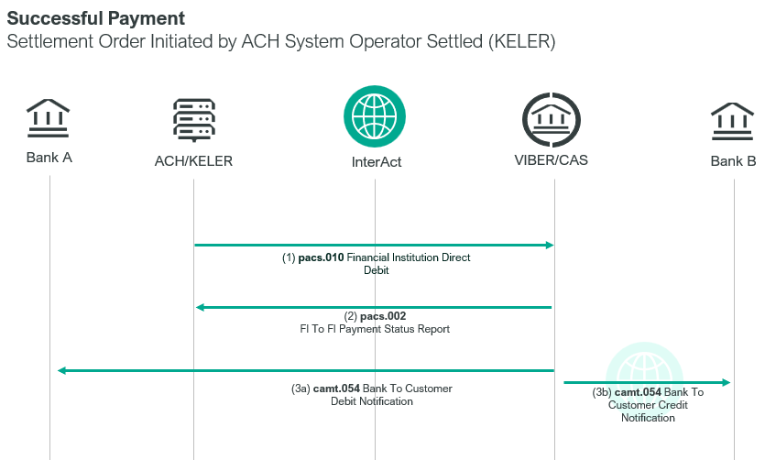

ICS participant shall submit their payment orders to GIRO Zrt. in accordance with the business terms and conditions of ICS. By GIRO Zrt’s settlement order in the form of an MX pacs.010.001.03 SWIFT message within the framework of the ICS intraday multiple clearing
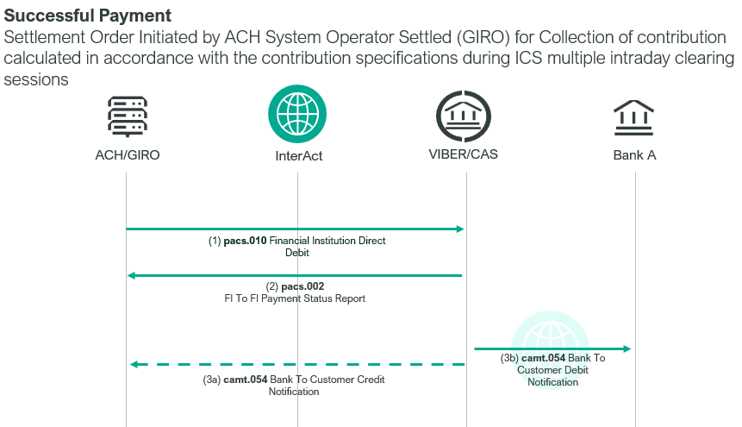
- collects participants’ financial obligations generated after ICS multiple intraday clearing from the respective accounts of ICS participants;

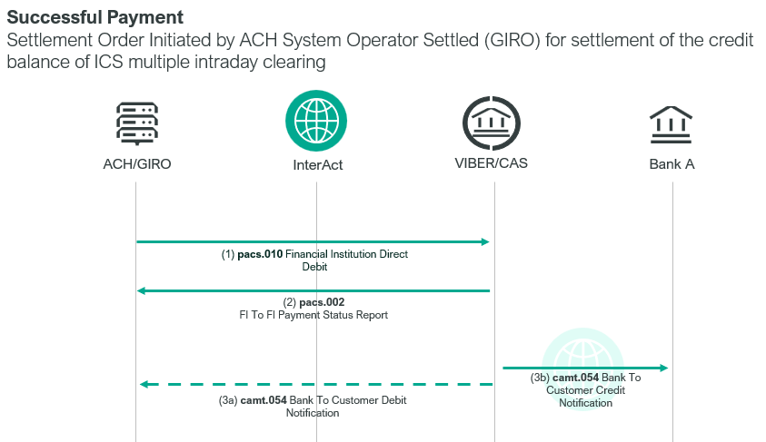
- after the execution of these, the positive closing balances resulting from the settlement and execution are transferred in VIBER to the bank accounts of the ICS participants,

- and, when there is an incident, the already collected collateral amounts are transferred back to the direct participants’ bank accounts that were debited previously.
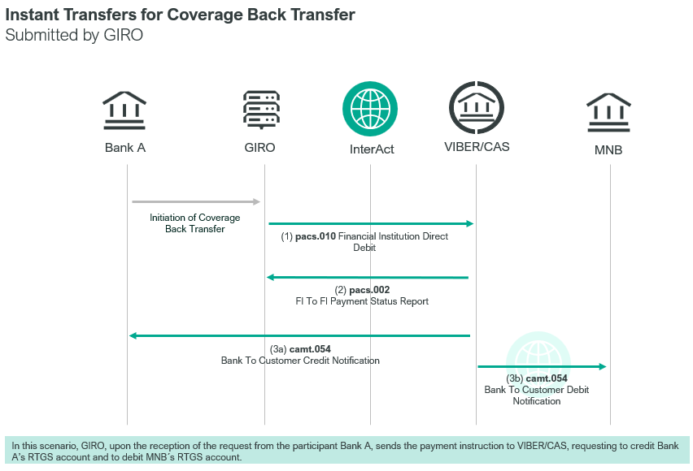
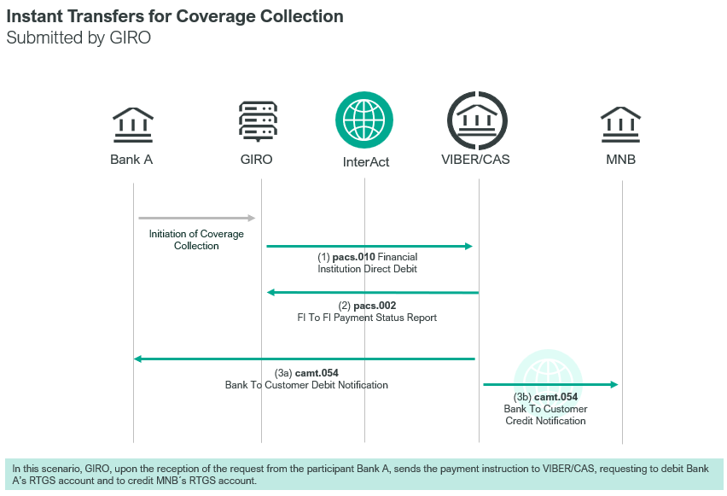
During the operating hours of VIBER, instant transfers between the direct participant’s bank account and the collective account take place by way of the MX pacs.010.001.03 message sent by GIRO Zrt.

Element specification
The below table includes the SWIFT format specification.
M/O | Element | MX options | MT equivalent field | MT equivalent field name
M | AppHdr/Fr/FIId/FinInstnId/BICFI | CAS settlement BIC | n/a
M | AppHdr/To/FIId/FinInstnId/BICFI | receiving BIC (MANEHU2AXXX) | n/a
M | AppHdr/BizMsgIdr | Business Message Identifier | n/a
M | AppHdr/MsgDefIdr | pacs.010.001.03 | n/a
M | AppHdr/BizSvc | swift.iap.01 | n/a
M | AppHdr/CreDt | Creation Date and Time | n/a
M | Document/FIDrctDbt/GrpHdr /MsgId | Message Identification | n/a
M | Document/FIDrctDbt/GrpHdr /CreDtTm | Creation Date and Time | n/a
M | Document/FIDrctDbt/GrpHdr /NbOfTns | Number of transactions, fixed value: 1 | n/a
M | Document/FIDrctDbt/CdtInstr /CdtId | Credit Identification | 20 | Transaction Reference Number
M | Document/FIDrctDbt/CdtInstr/InstgAgt/FinInstnId/BICFI | Instructing Agent | n/a | CAS Member BIC
M | Document/FIDrctDbt/CdtInstr/InstdAgt/FinInstnId/BICFI | Instructed Agent (MANEHU2AXXX) | n/a
M | Document/FIDrctDbt/CdtInstr/Cdtr/FinInstnId/BICFI† | Creditor BIC | L04  (Second) | CAS Member BIC (credit)
M | Document/FIDrctDbt/CdtInstr/DrctDbtTxInf/PmtId/EndToEndId | End To End Identification | n/a
M | Document/FIDrctDbt/CdtInstr/DrctDbtTxInf/PmtId/UETR | UETR | n/a
M | Document/FIDrctDbt/CdtInstr/DrctDbtTxInf/IntrBkSttlmAmt | Amount and Currency | 32A | Amount and currency
M | Document/FIDrctDbt/CdtInstr/DrctDbtTxInf/IntrBkSttlmDt | Interbank Settlement Date | 32A | Value date
O | Document/FIDrctDbt/CdtInstr/DrctDbtTxInf/SttlmPrty | Settlement Priority  HIGH,NORM or URGT | 113 | Priority
M | Document/FIDrctDbt/CdtInstr/DrctDbtTxInf/Dbtr/FinInstnId/BICFI† | Debtor BIC | L04 (First) | CAS Member BIC (debit)
 | Document/FIDrctDbt/CdtInstr/DrctDbtTxInf/InstrForDbtrAgt | Instruction For Debtor Agent | 72 | Sender to receiver information
O | Document/FIDrctDbt/CdtInstr/DrctDbtTxInf/Purp/Prtry | Numeric Priority | 113 | Priority

Format specification
- Document/FIDrctDbt/GrpHdr /MsgId: Message Identifier
The first four characters of this element are
- AFRC for coverage collection with instant transfer,
- AFRF for coverage back transfer with instant transfer
Missing ID characters can be specified optionally, but in consideration of the rules pertaining to individual IDs.
- Document/FIDrctDbt/CdtInstr/DrctDbtTxInf/Dbtr/FinInstnId/BICFI†: Debtor BIC
This element contains the BIC code of the party to be debited in the case of settlement orders and instant transfer orders submitted by system operators.
- Document/FIDrctDbt/CdtInstr/Cdtr/FinInstnId/BICFI†: Creditor BIC
This element contains the BIC code of the party to be credited in the case of settlement orders and instant transfer orders submitted by system operators.
- Document/FIDrctDbt/CdtInstr/DrctDbtTxInf/IntrBkSttlmDt: Interbank Settlement Date
Date of execution should always be the same as the date of sending the message.
Document/FIDrctDbt/CdtInstr/DrctDbtTxInf/IntrBkSttlmAmt: Currency Code, Amount
Currency code is always HUF.
- Document/FIDrctDbt/CdtInstr/DrctDbtTxInf/InstrForDbtrAgt: Instructions For Debtor Agent
Information in this element will be forwarded to the debit and credit party. This information is included in element Document/BkToCstmrDbtCdtNtfctn/Ntfctn/Acct/Prxy/Id of the camt.054 message.
‘Structured Text’ line format can be used with the following restrictions:
Line 1:
Sub-field 1: a codeword defined by MNB, e.g. : /SECURITY/, /IG2CCOLL/, /AFRCCOLL/, /AFRFUNDT/.
The BIC code of the direct participant involved in the instant clearing is to follow the codewords used for the instant transfer.
Sub-field 2: further information defined by MNB
Line 2 to 5:
According to the SWIFT MT standard
Line 6:
not needed.
- line break replaced with „::”
- /FIELD72/ added at start of first line if it does not begin with /
- // added at start of subsequent lines if they do not start with /
- line break added after 35 characters of any line longer than 35 characters.
Example: <InstrForDbtrAgt>/SECURITY/HU0000111222::19017004-00201373-00000000::TAG:0348::19017004-00201012-00000000::TAG:0410</InstrForDbtrAgt>
When SECURITY, KIFIZET, DAUKCIO and REPO codewords are used, the lines should be filled out as follows:
Line 1: codeword + ISIN code of the security
e.g.: /SECURITY/HU0000111222
Line 2: the account number of the seller to be credited, 3x8+2 characters long (with dashes, plus with zeros as padding characters for 16-character account numbers).
Line 3: TAG: and the code of the seller’s security account, 4 or 10 characters long
Line 4: the account number of the seller, 3x8+2 characters long (with dashes, plus with zeros as padding characters for 16-character account numbers).
Line 5: TAG: code of the buyer’s security account, 4 or 10 characters long
Example:<InstrForDbtrAgt>/SECURITY/HU0000111222::14400018-10361966-10010017::TAG:0348000000::19017004-00201177-00000000::TAG:0410123456</InstrForDbtrAgt>

In the event that IG2CCOLL is the codeword:
Line 1: codeword + IG2 session no. e.g. /IG2CCOLL/session1

In the event that IG2FUNDT is the codeword:
Line 1: codeword + IG2 session no. e.g. /IG2FUNDT/session1
Line 2: opening balance
e.g. //100,
Line 3: all outgoing items
e.g. //200,
Line 4: all incoming items
e.g. //300,
Example: <InstrForDbtrAgt>/IG2FUNDT/2/session1::10000000,::10000000,::30000000,</InstrForDbtrAgt>

In the event that IG2RFUND is the codeword:
Line 1: codeword: /IG2RFUND/
Line 2: Collected contribution
e.g. //1,
Line 3:
e.g. //0,
Line 4:
e.g. //0.
Example: <InstrForDbtrAgt>/IG2RFUNDT/::10000000,::0,::0,</InstrForDbtrAgt>
- Business Priority
The priority in Document/FIDrctDbt/CdtInstr/DrctDbtTxInf/SttlmPrty element can only be set to one of the following text values: URGT, HIGH or NORM. CAS is configured to define a numeric priority value for each of these; it is this configured numeric priority that is used as the business priority for the payment. MNB sets the priority value as follows:
URGT – 0012
HIGH – 0050
NORM – 0098
To add a numeric priority to a pacs.010 message, the Document/FIDrctDbt/CdtInstr/DrctDbtTxInf/Purp/Prtry tag should contain a numeric priority of exactly 4 digits in length, eg 0007.
Settlement orders submitted to KELER can use priority 0007, 0008 and 0009. KELER assigns security levels to the transaction orders depending on the type of the single security transactions. GIRO Zrt. may use priority 0004 for settlement orders related to ICS intraday multiple settlement and the instant internal transfer orders.

Examples
- OTP Bank buys securities from ING Bank for 10 million HUF on 05-08-2023. KELER sends the following pacs.010.001.03 message (Message Identifier: DVP/1) to CAS, requesting settlement of the transaction.
Account and security TAG data:
/SECURITY/HU0000111222
//19017004-00201373-00000000
//TAG:0348
//19017004-00201012-00000000
//TAG:0410
mnb.hu/letoltes/pacs-010-001-03-1-viber.txt
- OTP Bank buys securities from ERSTE Broker for 10 million HUF on 05-08-2023. KELER sends the following pacs.010.001.03 message (Message Identifier: DVP/1) to CAS, requesting settlement of the transaction.
Account and security TAG data:
/SECURITY/HU0000111222
//14400018-10361966-10010017
//TAG:0348000000
//19017004-00201177-00000000
//TAG:0410123456
mnb.hu/letoltes/pacs-010-001-03-2-viber.txt
- ING Bank buys securities from AKK on 05-08-2023 for 10,000,000 HUF. (Message Identifier: DVP/1)
Account and security TAG data:
/SECURITY/ HU0000111222
//14400018-10361966-10010017
//TAG:0348000000
//19017004-00201177-00000000
//TAG:0410123456
mnb.hu/letoltes/pacs-010-001-03-3-viber.txt
- OTP Bank buys securities for 20,000,000 HUF from MNB on 05-08-2023 at the time of bond release. (Message Identifier: DVP/1)
Account and security TAG data:
/DAUKCIO/HU0000111222
//19017004-01740060-01996003
//TAG:0348
//19017004-00201177-00000000
//TAG:0410
mnb.hu/letoltes/pacs-010-001-03-4-viber.txt
- Example of the collection of contribution calculated in accordance with the contribution specifications during ICS multiple intraday clearing sessions
On 28-10-2023 ING Bank submitted 1 transaction batch in an amount of HUF 10,000,000 in session 1 of ICS multiple intraday clearing; based on the set contribution specifications, HUF 10,000,000 in contribution is collected by GIRO Zrt. from ING Bank’s account (Message Identifier: IG2CCOLL/1).
mnb.hu/letoltes/pacs-010-001-03-5-viber.txt
- An example of the settlement of the credit balance of ICS multiple intraday clearing
HUF 30,000,000 is credited (Message Identifier: IG2FUNDT/2) to ING Bank’s account at the end of session 1 of ICS multiple intraday clearing (closing balance) on 28-12-2023. Opening balance: 10000000, outgoing items: 10000000, incoming items: 30000000.
mnb.hu/letoltes/pacs-010-001-03-6-viber.txt

- An example of cancellation settlements during ICS multiple intraday clearing sessions
GIRO Zrt. performs cancellation settlement on 28-12-2023, therefore ING Bank’s account is credited in an amount of HUF 10,000,000 by GIRO Zrt. on account of the back transfer of the contribution collected during ICS multiple intraday clearing. Opening balance: 10000000, outgoing items: 0, incoming items: 0. (Message Identifier: VISSZA)
mnb.hu/letoltes/pacs-010-001-03-7-viber.txt
- Example for coverage collection with instant transfer
On 02-08-2023 ING Bank wishes to deposit the coverage amount of HUF 10,000,000 to its collective account; accordingly, GIRO Zrt. initiates a coverage collection by debiting the account of ING Bank. (Message Identifier: AFRCOLL1)
mnb.hu/letoltes/pacs-010-001-03-8-viber.txt
- Example for coverage back transfer with instant transfer
On 02-07-2023 ING Bank requests the back transfer of the coverage amount of HUF 30,000,000 by way of debiting it to the collective account; accordingly, GIRO Zrt. submitting a payment order crediting the account of ING Bank (Message Identifier: AFRFUNDT1).
mnb.hu/letoltes/pacs-010-001-03-9-viber.txt

