pacs.002.001.10 Payment Status Report (MT equivalents: MT298/SMT701 – Payment Settlement Refusal Notification and MT298/SMT703 – Payment Settlement Notification)

Scope
Payment and settlement orders submitted by a pacs.010.001.03 SWIFT message may be cancelled or rejected in the following cases:
- CAS automatically rejects the payment and settlement order, when
  - CAS enters ‘closed for business’ status (cancellation at end-of-day closing);
  - a party involved in the transaction has been locked out (‘defaulted’ status);
  - date of execution of the payment or settlement order is older than the current date;
  - a payment or settlement order has been submitted in duplicate;
  - address validation failed;
  - debit or credit party is not a direct participant.
- MNB has cancelled the payment (intraday).
- KELER has cancelled the payment and settlement order with a camt.008.001.08 message (intraday).
In case the account transfer submitted by the MNB is cancelled or refused, including the end-of-day cancellation of queued transaction orders, the debit and credit direct participants receive a pacs.002.001.10 SWIFT message.
In case the settlement order (pacs.010.001.03) submitted by the system operator (KELER, GIRO Zrt.) is
- rejected by the CAS during the day or cancelled automatically at the end of the day, the system operator (KELER, GIRO Zrt.) and the debit party receive a pacs.002.001.10 SWIFTmessage,
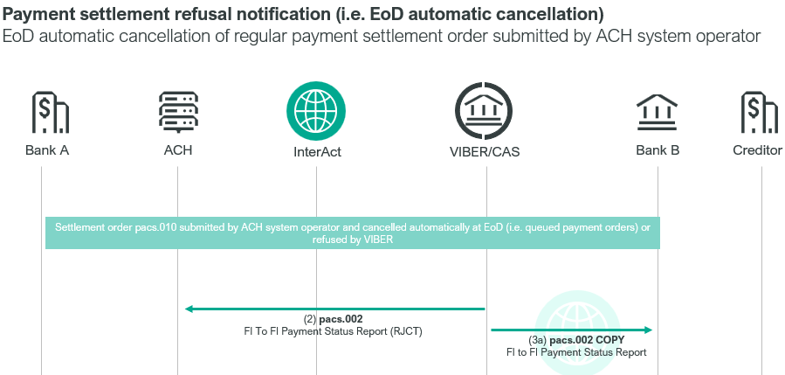
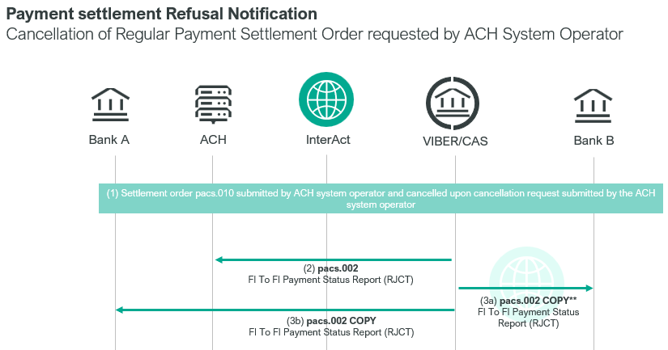
- cancelled by the submitter, the system operator and the debit and credit direct participants receive a pacs.002.001.10 SWIFT message.

In case the payment order (via pacs.008.001.08, pacs.009.001.08 SWIFT messages) submitted by the direct participant is cancelled by the VIBER participant or it is refused, including the case of end-of-day automatic cancellation, the debit party receives an xsys.003, and the credit party receives a pacs.002.001.10 SWIFT message.
(N.B.: If the account transfer and the settlement order are settled and executed, then the debited <direct participant> and the credited <direct participant> receive a camt.054.001.08 SWIFT message through VIBER.)
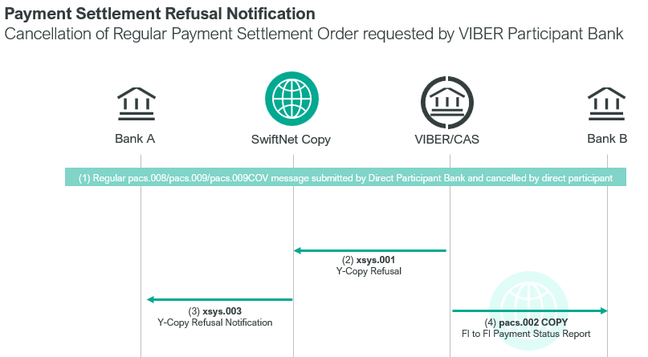

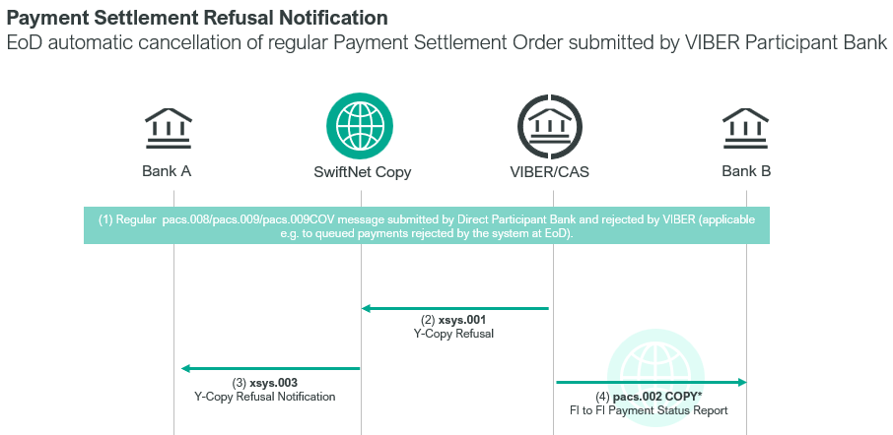
Notification of settlement and execution of payment and settlement orders of system operators
KELER and GIRO Zrt receive a pacs.002.001.10 SWIFT message from CAS if the pacs.010.001.03 SWIFT message sent by GIRO Zrt. or KELER has been settled. Direct participants receive camt.054.001.08 messages for the settlement and execution of settlement orders and instant internal transfer orders submitted by system operators with CRDT or DBIT codeword in the Document/BkToCstmrDbtCdtNtfctn/Ntfctn/Ntry/CdtDbtInd element.
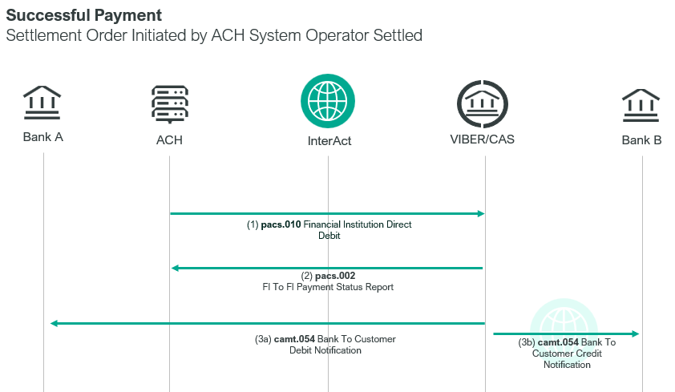

Element specification
The below table includes the SWIFT format specification.
M/O | Element | MX options | MT equivalent field | MT equivalent field name
M | AppHdr/Fr/FIId/FinInstnId/BICFI | Sender BIC (MANEHU2AXXX) | n/a
M | AppHdr/To/FIId/FinInstnId/BICFI | Receiving BIC | n/a
M | AppHdr/BizMsgIdr | Business Message Identifier | n/a
M | AppHdr/MsgDefIdr | pacs.002.001.10 | n/a
M | AppHdr/BizSvc | swift.iap.01 | n/a
M | AppHdr/CreDt | Creation Date and Time | n/a
M | Document/FIToFIPmtStsRpt/GrpHdr/MsgId | Message Identification | 20 | Transaction Reference Number
M | Document/FIToFIPmtStsRpt/GrpHdr/CreDtTm | Creation Date and Time | n/a
M | Document/FIToFIPmtStsRpt/TxInfAndSts/OrgnlGrpInf/OrgnlMsgId | Original Message Identification | 21 | Related Reference
M | Document/FIToFIPmtStsRpt/TxInfAndSts/OrgnlGrpInf/OrgnlMsgNmId | Original Message Name Identification | n/a
M | Document/FIToFIPmtStsRpt/TxInfAndSts/OrgnlEndToEndId | Original E2E Identification  if set, otherwise Message Identifier of payment | n/a
M | Document/FIToFIPmtStsRpt/TxInfAndSts/OrgnlUETR | Original UETR  if set, otherwise new UETR | n/a
M | Document/FIToFIPmtStsRpt/TxInfAndSts/TxSts | Transaction Status  “RJCT” – rejected  “CANC” – cancelled  “ACSC” - accepted
M | Document/FIToFIPmtStsRpt/TxInfAndSts/StsRsnInf/Rsn/Cd | fixed value: “NARR” | n/a
O | Document/FIToFIPmtStsRpt/TxInfAndSts/StsRsnInf/AddtlInf | Additional Information | L02 | CAS Message Details
O | Document/FIToFIPmtStsRpt/TxInfAndSts/StsRsnInf/AddtlInf | Additional Information  only if the Transaction Status is RJCT or CANC | L10 | CAS Message Status  without message line  third character removed
M | Document/FIToFIPmtStsRpt/TxInfAndSts/InstgAgt/FinInstnId/BICFI | Instructing Agent (MANEHU2AXXX) | n/a
M | Document/FIToFIPmtStsRpt/TxInfAndSts/InstdAgt/FinInstnId/BICFI | Instructed Agent BIC | n/a

Format specification
- Document/FIToFIPmtStsRpt/TxInfAndSts/OrgnlGrpInf/OrgnlMsgId
This element includes the Message Identifier of the rejected or cancelled pacs.008.001.08/pacs.009.001.08 /pacs.009.COV/pacs.010.001.03 SWIFT message.
- Document/FIToFIPmtStsRpt/TxInfAndSts/OrgnlGrpInf/OrgnlMsgNmId
This element includes the Message Definition Identifier of the original transaction, e.g. “pacs.008.001.08”, “NONE” for account transfer.
- Document/FIToFIPmtStsRpt/TxInfAndSts/OrgnlEndToEndId contains the Message Identifier of the related transaction.
- Document/FIToFIPmtStsRpt/TxInfAndSts/StsRsnInf/AddtlInf first occurrence is related to the refused account transfer.
This element must be populated with the former MT L02 field, which identifies transaction or settlement order.
  - 1x = credit or debit flag – “C” or “D” – in case of submitted by a system operator it is always “S”
  - 6n = settlement date of the original transaction: yymmdd, e.g. “231028”
  - 3x = message type, e.g. “008” (in case of pacs.008.001.08 messsage)
  - 3x=message subtype. If this message does not have a subtype, then it contains the same value as that of the message type. If the transaction is an account transfer the message type will be TRF, just like the message subtype.
  - 11a = BIC code of the sender.
  - 35x = Message Identifier of the message
E.g.: :L02:S230805010010KELRHUHBXXXDVP/1
- Document/FIToFIPmtStsRpt/TxInfAndSts/StsRsnInf/AddtlInf second occurrence indicates the reason for refusal or cancellation.

The most frequent codes:
LN00 | Payment has been settled
LT00 | Payment is awaiting settlement
LT01 | Payment is held
LF00 | Invalid message contents
LF01 | Invalid BIC code
LF02 | Invalid codeword
LF03 | Message contains unexpected field
LA70 | Rejected due to validation error
LA71 | Rejected because sender or receiver direct participant is unknown
LA72 | Aborted on entry or when queued and the settlement status for the payment type has been set to ‘closed’, ‘rejecting’ or ‘finished’ (i.e. CAS has stopped accepting or processing payments of this type)
LA73 | Refused due to invalid value date
LA74 | Refused because submitted payment order type is not permitted
LA75 | Not used
LA76 | Refused because direct participant has been suspended (default status)
LA77 | Duplicate message
LA78 | Invalid message
LA79 | Payment order has already been cancelled
LA80 | Failure in CAS operation
LA81 | Invalid message format
LA82 | Order cannot be completed due to insufficient cover and has been refused (the VIBER does not permit the sender of the given message to queue their transaction orders if there is no sufficient cover).
LA83 | The amount of the order is less than the minimum allowed amount for this message type
LA84 | Not the appropriate account to be debited
LA85 | Not the appropriate account to be credited
LA86 | Rejected by AML Filter
LA87 | Rejected by operator

Examples
- Due to correcting an error MNB wanted to carry out an account transfer between OTP Bank and UniCredit Bank, but it was refused by CAS because an invalid date of execution was entered (LA73). Message Identifier of the account transfer was: SZT231012008. OTP Bank that would have been debited during the transfer will receive the following pacs.002.001.10 SWIFT message.
mnb.hu/letoltes/pacs-002-001-10-1-viber.txt
- OTP Bank buys securities from K&H Bank for 10 million HUF. KELER applied for the settlement and execution of this transaction in VIBER by a pacs.010.001.03 SWIFT message. Later, on the request of OTP Bank, they sent a cancellation request in a camt.008.001.08 SWIFT message to VIBER for the same settlement order. KELER received the following pacs.002.001.10 SWIFT message about the cancellation of the settlement order.
mnb.hu/letoltes/pacs-002-001-10-2-viber.txt
- GIRO Zrt. submitted a pacs.010.001.03 settlement order in VIBER for the contribution established in session 1 of ICS multiple intraday clearing. Later GIRO Zrt. submitted a camt.008.001.08 cancellation order in VIBER in respect of this transaction order. GIRO Zrt. as a direct participant submitting the order receives the following pacs.002.001.10 SWIFT message on the cancellation of the order.
mnb.hu/letoltes/pacs-002-001-10-3-viber.txt
- GIRO Zrt. submitted a pacs.010.001.03 settlement order in VIBER for the contribution established in session 1 of ICS multiple intraday clearing from a CITIBank account, however, CAS rejects the order, because an unacceptable execution date (LA73). The Message Identifier of the settlement order was MAN2311050402. CITIBank as debit party receives the following pacs.002.001.10 SWIFT message:
mnb.hu/letoltes/pacs-002-001-10-4-viber.txt
- KELER receives a pacs.002.001.10 SWIFT message on the execution of a settlement order submitted by a pacs.010.001.03 SWIFT message of DVP/1 Message Identifier.
mnb.hu/letoltes/pacs-002-001-10-5-viber.txt
- GIRO Zrt. receives a pacs.002.001.10 SWIFT message on the settlement and execution of a settlement order submitted by a pacs.010.001.03 SWIFT message of IG2CCOLL/1 Message Identifier.
mnb.hu/letoltes/pacs-002-001-10-6-viber.txt
- GIRO Zrt. receives a pacs.002.001.10 SWIFT message on the settlement and execution of the payment order submitted by a pacs.010.001.03 SWIFT message of AFRCCOLL1 Message Identifier.
mnb.hu/letoltes/pacs-002-001-10-7-viber.txt
- GIRO Zrt. receives a pacs.002.001.10 SWIFT message on the settlement and execution of the payment order submitted by a pacs.010.001.03 SWIFT message of AFRFUNDT1 Message Identifier.
mnb.hu/letoltes/pacs-002-001-10-8-viber.txt
- GIRO Zrt. receives a pacs.002.001.10 message on the settlement and execution of the payment order submitted by a pacs.010.001.03 SWIFT message of AFRFUNDT2 Message Identifier.
mnb.hu/letoltes/pacs-002-001-10-9-viber.txt

