Pacs.004.001.09 Payment Return - Return of a transaction order (RETURN)

Scope
The Payment Return message is exchanged between agents to return funds after settlement of credit transfer instructions (that is FIToFICustomerCreditTransfer message and FinancialInstitutionCreditTransfer message) or direct debit instructions (FIToFICustomerDirectDebit message).
CAS does not look at the original payment information contained in the pacs.004 message, and does attempt to connect the return payment to the original payment.
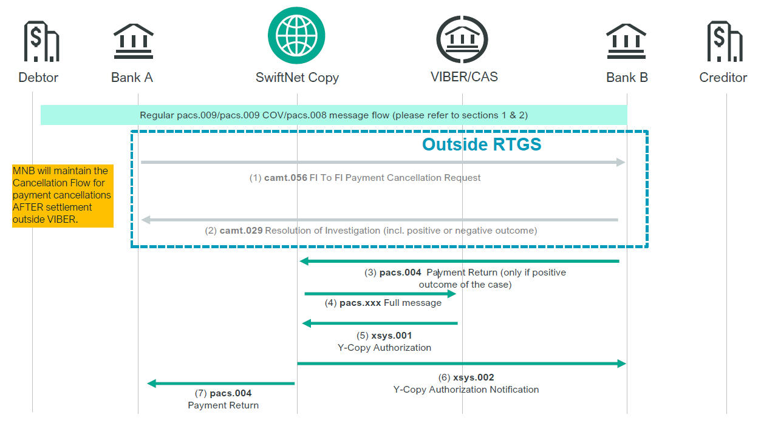

Element specification
The below table includes the SWIFT format specification.
M/O | Element | MX options | MT equivalent field | MT equivalent field name
M | AppHdr/Fr/FIId/FinInstId/BICFI | CAS settlement BIC = Debit party=Instructing Agent
M | AppHdr/To/FIId/FinInstId/BICFI | Credit party=Instructed Agent
M | AppHdr/BizMsgIdr | Business Message Identifier
M | AppHdr/MsgDefIdr | pacs.004.001.09
M | AppHdr/BizSvc | swift.iap.02
M | AppHdr/CreDt | Creation Date and Time
M | Document/PmtRtr/GrpHdr/MsgId | Message Identification
M | Document/PmtRtr/GrpHdr/CreDtTm | Creation Date and Time
M | Document/PmtRtr/GrpHdr/ NbOfTxs | Number of Transactions - fixed value: “1”
M | Document/PmtRtr/GrpHdr/SttlmInf/SttlmMtd | Settlement Method – fixed value: “CLRG”
M | Document/PmtRtr/GrpHdr/SttlmInf/ClrSys/Cd | Clearing System Code - fixed value: “HUF” | 103 | Service Code
M | Document/PmtRtr/TxInf/RtrId | Return Identification | 20 | Transaction Reference Number
M | Document/PmtRtr/TxInf/OrgnlEndToEndId | Original End-to-End Identification
M | Document/PmtRtr/TxInf/OrgnlUETR | Original UETR
M | Document/PmtRtr/TxInf/RtrdIntrBkSttlmAmt | Returned Amount and Currency | 32A | Currency Code, Amount
M | Document/PmtRtr/TxInf/IntrBkSttlmDt | Settlement Date
O | Document/PmtRtr/TxInf/SttlmPrty | Settlement Priority: URGT/HIGH/NORM
O | Document/PmtRtr/TxInf/ClrSysRef | 4-character numeric priority
M | Document/PmtRtr/TxInf/InstgAgt/FinInstnId/BICFI | Instructing Agent = Debit Party
M | Document/PmtRtr/TxInf/InstdAgt/FinInstnId/BICFI | Instructed Agent = Credit Party
M | Document/PmtRtr/TxInf/RtrChain/Dbtr | Debtor | 50a | Ordering Customer
M | Document/PmtRtr/TxInf/RtrChain/Cdtr | Creditor | 59a | Beneficiary Customer
M | Document/PmtRtr/TxInf/RtrRsnInf/Rsn/Cd | Return Reason Code

Format specification:
- Priority
/Document/PmtRtr/TxInf/SttlmPrty element contains 3 values (URGT, HIGH, NORM). MNB sets the priority value as follows: URGT=12, HIGH=50, NORM=98
/Document/PmtRtr/TxInf/ClrSysRef element contains a 4-character numeric priority.
If both of these priority fields are present in the inbound SWIFT message, then the new numeric priority will be used as the priority of the payment. If only one of these fields is present, then that will be used as the priority of the payment. If neither field is present, then a default priority will be assigned to the payment in the standard.
- Document/PmtRtr/TxInf/RtrdIntrBkSttlmAmt
The amount shown in Document/PmtRtr/TxInf/RtrdIntrBkSttlmAmt element of the returned transaction order should be the same as the one entered into Document/FIToFICstmrCdtTrf/CdtTrfTxInf/IntrBkSttlmAmt (pacs.008.001.08) or Document/FICdtTrf/CdtTrfTxInf/IntrBkSttlmAmt (pacs.009.001.08) element of the original message.
- Document/PmtRtr/TxInf/RtrChain/Dbtr
This element should be a copy of Document/FIToFICstmrCdtTrf/CdtTrfTxInf/Cdtr element of the original pacs.008.001.08 message.
- Document/PmtRtr/TxInf/RtrChain/Cdtr: Beneficiary Customer
This field should be a copy of field Document/FIToFICstmrCdtTrf/CdtTrfTxInf/Dbtr element of the original pacs.008.001.08 message.
- Document/PmtRtr/TxInf/RtrRsnInf/Rsn/Cd: Return reason code
The standard SWIFT code of the reason for rejection should be entered into this element. Rejection codes are published by SWIFT in an external reason code list. The list can be downloaded from www.iso20022.org .

Example:
Original message:
A resident customer of UniCredit Bank (account number: 10918001-11157590-01000004) pays 100.000.000 HUF to a resident customer of OTP Bank (account number: 11794008-11111111-11111111) with priority 30 on 18-10-2023.
Return
OTP Bank could not credit the pacs.008001.08 message (TRN:CUSTOMER6) received from UniCredit Bank to the customer, e.g. because the above account number is not associated with any customers as the account was cancelled 1 month ago.
On 18-10-2023 the transaction order was returned by OTP Bank to UniCredit Bank with priority 30, using a pacs.004.001.09 SWIFT message.
mnb.hu/letoltes/pacs-004-001-09-1-retn-viber.txt

